**Genetic Diversity Assessment, BLUP Modeling & Revealing the Effects of Phytohormone on Post-Fertility Traits of Mung-bean Genotypes under Rain-fed Condition in Nepal.**

**ABSTRACT**

This study in Chitwan, Nepal, endeavors to quantify genetic diversity, identify stable elite genotypes, and assess the response of exogenous foliar application of standard rates (50 mg/L IAA or NAA + 50 mg/L GA3) to 14 post-flowering phenotypes in 16 mung bean genotypes. A single-factor randomized complete block design experiment with three replications was conducted to perform multivariate selection using principal component analysis (PCA), cluster analysis, Multi Genotype Ideotype Distance Indexing (MGIDI), genetic parameters and Analysis of variance with Duncan's multiple range test at p ≤ 0.05 to compare the means of yield- attributes. This study revealed that nine eigenvalues larger than one contributed 92.13% of the variability. The first three **PC**s accounted for the maximum of the total variances, with 32.48%, 13.56%, and 12.07%. Biological yield/hectare, harvesting index, straw yield/hectare, plot yield, 100-grain weight, length of pod, grains /pod, dimension of seed present in all 3 PCs and exhibited mean values that surpassed the predefined threshold; positively gain to grain yield. Flower shedding before and 12 hours after spraying is deleterious to grain yield. Elbow technique elucidate that genotypes were grouped into 4 clusters having dissimilarity coefficient of variation of 0.172 and intra and inter-clusters distance is 440.6(C1-C1) and 5959.402(C1-C2) indicating significant genetic variation and potential for use in cross-breeding and selection. Plus, sign cluster biplot genotypes unveil the highest yield-related traits, such as harvesting index and hundred grain weight. Biological yield/plot is correlated (p<0.01, r=0.79) with harvesting index and hundred seed weight (p<0.001, r=0.83). Estimates of genetic (GCV) and phenotype coefficient (PCV) variation ranged from 9% to 69.3% and 12% to 104%, respectively. Heritability(H2) ranged from 15% to 1%, and the expected genetic gain as a percentage of the mean (GAM) ranged from 13% to 63.13%. All traits show high or moderate variability components (GCV, PCV, H², and GAM) except seed diameter 8% of GCV and pods per cluster (15.7% of H²), which appears low variability. All multivariate approaches indicate that VC6370A and CN95 are the ideal growth substance responsive stable genotypes for yield(2.8tons/ha) and has scope in breeding.

**Keywords: Mung bean improvement, Multivariate selection, Genetic potential, Growth promoters, Ideal genotypes, High yield, Future breeding**

**INTRODUCTION**

Mung bean in the tropics and subtropics is a legume crop that grows quickly (55-75 days) and pollinates itself. It has 22(diploid) chromosomes, except for the variety V. *reflexa pilosa*, which has 44(Tetraploid). The experimental variety V. radiata var. radiata VC1973A and its relatives has a genome size of 475-579.35 million base pairs[1][2]. Mung bean is a low-cost source of nutrients, including 60-65% carbohydrates, 20.97-31.32% protein (compared to 20-30% in soy and kidney beans), and 1-1.5% fat content. It is also a rich source of iron and folate reviewed by [3][4][5]. Mung bean is widely grown in Nepal's Terai region, particularly in the eastern and central regions where irrigation is accessible. The western Terai and foothills account for the remaining 25% of mung bean production. About 12,000 hectares are used for mung bean farming, yielding a yield of 6,500 metric tons and a productivity of 600 kg per hectare indicating the low production of grain compared with global average Production of 2.8 to 3 tons/ha(Krishi Diary ,2079). Mung bean production is often challenged by climate crisis such as severe droughts, poor and inappropriate agricultural practices, and insufficient breeding efforts to develop new mung bean varieties with desirable traits such as high yield, drought tolerance, and disease resistance. These challenges can significantly reduce yield stability and harm the livelihoods of smallholder farmers.

**Genetic diversity is essential for improving the climate resilience of mung bean genotypes with different genetic backgrounds and farmers can reduce the risk of crop failure if one genotype is susceptible to a particular stress.** **Crop improvement programs rely on the genetic diversity of genotypes, which can be assessed by characterizing their morphological and agronomical traits. Exploiting this diversity to develop new varieties is highly rewarding**[7]. Grain yield in green gram is a complex trait influenced by several interconnected contributing factors. Crosses between parents with the greatest genetic diversity are generally the most responsive to genetic improvement. Phenotypic selection of highly heritable and genetically advanced traits contributing to grain yield would aid in the identification of superior genotypes for increasing green gram grain yield[8]. PCA can be used to reveal the most important traits for yield and the best genotypes for maximum yield and its attributes[9]. Grouping of genotypes in biplots was highly congruent with the dendrogram results, indicating the principal component, which accounted for most of the total variance, is the most important trait for selecting the best genotypes[10]. Thus, In this study, PCA was used to identify and remove duplicate genotypes with similar trait[11]. This helps to identify and select promising genotypes for recommendation and improvement. Best Linear Unbiased Prediction (**BLUP) modeling can be used to predict the genetic value of individual plants. Selection indexes are a better way to improve selection efficiency because they allow for the simultaneous selection of multiple traits, resulting in genotypes that are closer to the ideal**. The biggest drawback of the classic linear selection index is the need to specify the economic weight of each trait, genotypic and phenotypic variances and covariances, and its vulnerability to multicollinearity[12].The stability index proposed by [13] allows for the selection of stable genotypes with favorable selection differentials for traits to be increased and unfavorable selection differentials for traits to be decreased. The index technique used by [14]can also be used to assess the strengths and weaknesses of genotypes. This stability index is thus useful for simultaneously selecting for average performance and stability across multiple traits. It provides a unique and easy-to-interpret selection process that takes into account the correlation structure among traits.

**Mung bean plants have indeterminate pod maturity, meaning that they continue to produce flowers and pods throughout the growing season. This requires multiple harvests to avoid wasting pods. Phytohormones, which are plant hormones that regulate many aspects of plant growth and development, can be used to improve several mung bean post-fertility traits, including pod number, seed number, seed weight, and seed quality[15].**Nitrate reductase activity is increased by GA3, leading to higher protein content in cowpea, black cumin, and mungbean[16]**. Exogenous application of phytohormones may affect FERONIA, a known flowering-pathway gene that is a candidate for the quantitative trait locus (QTL) with the largest effect on days to flowering in mungbean [3]. Similarly, another study showed that mung-bean homologs of two soybean flowering genes, E3 (phytochrome A) and J (early flowering 3); can be used to improve post-fertility traits such as pod number, seed number, and seed weight[17].**

**Statement of the Problems**

**Mung bean has tremendous production potential in Nepal, but flower shedding and poor seed setting in pods are major problems in farmers' fields. Exogenous application of phytohormones on cucurbit crops has been documented in Nepal, but the use of standard researched rates of plant growth-promoting substances in mung bean germplasm has not been practiced.** **This study assumed that using GA3 (25 mg/L) and NAA (25 mg/L) together would improve the flow of nutrients from the leaves to the seeds and pods of mung bean plants after flowering, which would increase production.** **An additional challenge lies in the asynchronous maturation of mung bean; highlighting the influence of intricate genetic traits and varying environmental factors among tested germplasm on yield. The assessment of phenotypic trait expression through the characterization of morphological and agronomic features is crucial for identifying and enhancing the most promising genotypes. Regrettably, these breeding techniques are currently underutilized in Nepal for the purpose of selecting stable and high-performing genotypes. As a result, this study employed advanced multivariate and mixed-model methodologies, such as Principal Component Analysis (PCA) and Factor Analysis of Information-Best Linear Unbiased Prediction (FAI-BLUP), to identify disparities in the morphological characteristics of introduced mung bean genotypes and pinpoint optimal elite lines. These techniques serve to minimize errors in the economic evaluation of traits and their transformation into practical economic weightings by eliminating concerns related to weighting coefficients and multicollinearity. Thus, aim of this study is to investigate the genetic diversity of mung beans traits, select the stable elite genotypes, impact of phytohormone foliar application on the yield and to provide recommendations for breeders and farmers.**

**Objectives**

**General objectives**

* To study the significance of phytohormone foliar application for the fertility and yield-related attributes of Mung bean germplasm.
* To select and assess the ideal, stable genotype and diversity through multivariate analysis.

**Specific Objectives**

* To assess the impact of phytohormone foliar application on yield parameters such as pod number, pod length, number of seeds per pod, and seed weight in mung bean genotypes in Chitwan, Nepal.
* To determine whether there are any significant differences in the post-fertility performance of mung bean genotypes treated with phytohormone foliar application.
* To identify which mung bean genotype performs better under phytohormone foliar application in terms of growth, yield, and stability in Chitwan, Nepal.
* To conduct a Genetic Diversity assessment of the Mung beans through Principal Component Analysis, Cluster Graphics, and Best Linear Unbiased Prediction for Crop Ideotype Modeling, for stability analysis.
* To provide scientific information and recommendations for breeders and farmers regarding the potential ideal genotypes and the use of phytohormone foliar application to select stable and well-performing bean genotypes in Chitwan, Nepal.

**Systematic Review of the Literature:**

**Materials and Methods**

**Source of mung-bean germplasm:**

The germplasm utilized in this study comprised 13 exotic mung-bean genotypes and three promising cultivars. The exotic genotypes were sourced from the Grain Legumes Research Program at NARC (Nepal Agricultural Research Council) in Khajura, Bake, Nepal. A significant portion of these exotic collections was acquired from Taiwan. The genotypic information of the germplasm is presented in **Supplementary file.**

**Experimental site & design**

The experiment was carried out during the summer season, spanning from March 22 to June 7, at the Agriculture and Forestry University (AFU), Rampur, agronomy research Unit. The field experiment was designed using a Randomized Complete Block Design (RCBD) with a single factor, involving 16 different mung-bean germplasm treatments. These treatments were replicated three times, and two blocks were established perpendicular to a fertility gradient within the single replication. Each individual plot measured 4.62 square meters, with dimensions of 2.8 meters by 1.65 meters. In each plot, there were seven rows, and each row contained 11 plant spots, with dimensions of 40 by 15 centimeters (40 × 15-RR×PP), resulting in a total of 77 plant spots per plot Figure 1. The entire research area covered 430 square meters, with dimensions of 27.9 meters by 15.4 meters. To prepare the field for sowing, it underwent two rounds of harrowing and concurrent leveling to ensure uniformity. Fertilizers were applied as recommended, with 500 kilograms of farmyard manure (FYM) per hectare added three days before sowing. Additionally, Nitrogen, Phosphorus, Potassium (N, P, K) were applied at rates of 20:40:20 kilograms per hectare, five hours before sowing. The first weeding operation was conducted 15 days after sowing, followed by another weeding before the onset of flowering. In response to severe drought conditions, a single round of flooding irrigation was administered three days before sowing and Irrigation was withheld during approximately 50% of the flowering phase due to rainfall occurring 53 days after sowing.

Seeds were sown on March 22 to get the optimal yield, as detailed by [18]. To achieve germination synchronization, the seeds underwent hydro-priming, where 100 grams of seeds were soaked in a water solvent at a 1:1 weight-to-volume ratio for six hours, maintaining a controlled temperature of 25±1°C. described by [19].

Figure 1 Representation of the Experiemental demo plot and GIS map of the Research site

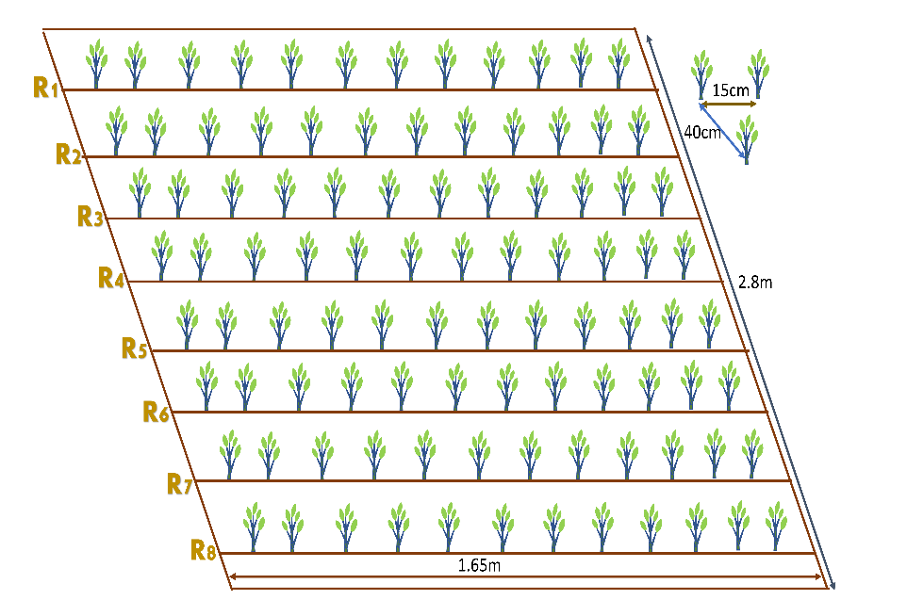

**Soil Properties and Observed traits**

Based on the soil data of the experiment site, the soil is sandy loam with an acidic pH of 5.52. The soil has medium organic matter content (3.42%), medium total nitrogen content (0.20%), medium total phosphorous content (10.5 ppm), and low total potassium content (5.5 ppm) Table 1.

Table 1 Methods for examining soil properties at the research site.

|  |  |  |  |
| --- | --- | --- | --- |
| S. N | Soil Property | Value/Rating | Method of Extraction |
| 1 | Sand% | 49.3 | The textural triangle of USDA |
| 2 | Slit% | 34.9 | The textural triangle of USDA |
| 3 | Clay% | 15.8 | The textural triangle of USDA |
| 4 | Textural Class | Sandy Loam | Determined by Marshall’s triangular coordinates by USDA system |
| 5 | PH | 5.52(Acidic Nature) | Digital pH Meter |
| 6 | Organic Carbon% | 3.201 | 58% of OM = Organic Carbon |
| 7 | Organic Matter | 3.42(medium) | (1-S/B)0.6810=3.42 because I have 11.6 and 23.4 value of S and B. (Walkley and Black method) |
| 8 | Total N% | 0.20(Medium) | Micro-K-jeldal Method |
| 9 | Total Phosphorous | 10.5 ppm(medium) | Modified Olsen's Bicarbonate Method |
| 10 | Total Potassium | 5.5ppm(low) | Flame photometer method |

**Meteorological features of the study site**

The weather parameters were recorded at the weather station of the National Maize Research Programme (NMRP) in Rampur, Nepal, 500 meters away from the research station. The 3-year weather pattern for the mung bean cultivation season is given **Figure 2**.

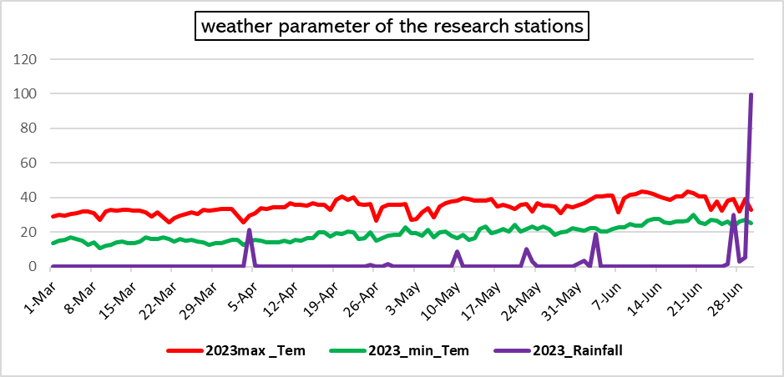

**Figure 2 Evaluating Meteorological Data of Research Stations from Weather Stations**

**Description of Phytohormones and Stickers and its Application.**

Enhancing Mung-Bean Growth and Yield through Foliar Spray of 50 mg/l IAA or NAA + 50 mg/l GA3 is the most recommended rate for sandy loam soil described by[20][15]. In this study, the utilization of phytohormones was carried out using this standardized approach. Specifically, Gibberellic Acid (GA3), Gib Max, sourced from Vee Aar Industries in West Bengal, India, with a 20% active ingredient (20g AI/100g powder), was applied at a concentration of 50 mg/L. Alpha Naphthaleneacetic Acid (NAA), Plano-fix, produced by Bayer Crops Science Limited in Mohali, Punjab, was applied using a battery-powered knapsack sprayer at the same concentration level (50 mg/L) in a 4.5% SL formulation. The application rate involved delivering half of the prescribed dosage of phytohormones via foliar spray 30 days after sowing, and then applying the remaining half during flowering, which typically occurs on day 54 post-sowing (DAS). 1,000 liters of water per hectare (equivalent to an area of 10,000 square meters) were used as solvents for these applications. Gorkha Stickermore, produced by Gorkha Agrochemical Pvt. Ltd., was added at a concentration of 0.5 ml/L to enhance phytohormone efficiency, completing this process, which was carried out only in the evenings.

**Model of the SPADE (Soil Plant Analysis Development Meter)**

This involves the determination of the Chlorophyll content index for a specific leaf surface area. The values obtained from leaf measurements are typically unitless and are commonly represented in SPAD units, or in the case of the Minolta SPAD-502, as the percentage transmittance ratio, which corresponds to the Chlorophyll Content Index (CCI) [21][22].

Where, and are the measured leaf light transmission intensities at the specific (in each measurement) infrared and red wavelengths and and are the light intensities of the **Infra-Red light** source and the **Red Led light** source. By calibrating the SPAD meter against a reference technique for detecting chlorophyll concentration, such as chemical extraction, the calibration coefficient, k, and the constant, C, are established. The wavelength of light is indicated in nano meters (nm) in the equations above by the numbers enclosed in parentheses.

**Multiple Traits Correlation and Regression analysis with Yield**

**LINEAR REGRESSION EQUATION MODEL**

Regression analysis quantifies the extent of influence exerted by independent variables on the response variable. The p-value serves as an indicator of the statistical significance of the relationship between the dependent and independent variables, while the coefficient reveals both the direction and strength of this relationship. In research, the primary goal of regression analysis is to identify the significant predictors of the dependent variable and to ascertain the magnitude and direction of the relationships between the variables. The model employed in this study adheres to the following equation[23].

Where Y (e.g., "Grain yield ton/ha") is the dependent variable, X (e.g., "Harvesting Index of the Crops") is the independent variable, β0 is the intercept (the value of Y when X is 0), β1 is the slope (the change in Y for a one-unit change in X), and ε represents the error term.

**Pearson correlation coefficient (r) Model**

The correlation coefficient, denoted as 'r,' quantifies the strength and direction of the linear relationship between two variables. It falls within the range of -1 to 1, with a value of 0 signifying the absence of a linear relationship. The following equation is employed for the correlation analysis of Mung-bean descriptors.

Where, and are individual data points and and are the means of ***X*** and ***Y***, respectively.

**Yield Calculation Model**

The grain yield per hectare for each genotype was calculated from the net plot yield, taking into account the moisture content of the seed. The moisture content of each plot was measured using an automated moisture meter, and the final grain yield was adjusted to a moisture level of 10% using the following formula[24].

The moisture content (MC) is expressed as a percentage of the grain's weight. The straw yield was determined by subtracting the seed yield from the total biological yield (measured in kilograms per hectare). After completely sun-drying the harvested produce, the weight of grain and straw from each plot was recorded separately using a spring balance, and the measurements were noted in kilograms per plot. Subsequently, the per-plot biological yield was converted to kilograms per hectare. The collective yield of all plant materials is referred to as the biological yield, and the ratio of grain yield to biological yield is known as the harvest index, as defined by[25].

***Cluster Analysis of Mung Bean Genotypes and Promising Cultivars***

**Euclidean distance Calculation and Cluster Analysis.**

Euclidean distance serves as a widely adopted metric for gauging dissimilarity in cluster analysis. It is formally defined as the square root of the summation of squared disparities between corresponding elements of two vectors, x and y, across multiple dimensions. In essence, the smaller the Euclidean distance between two data points, the more akin they are. Consequently, data points positioned closely together in Euclidean space are predisposed to sharing the same cluster. K-means clustering, on the other hand, represents a straightforward yet efficient algorithm for partitioning data points into a predetermined number of clusters. This iterative procedure hinges on assigning data points to the cluster whose centroid is nearest to them. The centroids, in this context, are the average values of data points within each cluster. In this specific study, K-means clustering was employed subsequent to the calculation of Euclidean distances governed by following equation (Becker, R. A., Chambers, J. M., & Wilks, A. R. (1988). The new S language. Wadsworth and Brooks/Cole computer science series. Pacific Grove).

**Genotype analysis by mixed-effect models**

Analysis of genotypes in single experiments using mixed-effect models with estimation of genetic parameters.

Where,   is the response variable of the ith  genotype in the *j*th block/replications; *m* is the grand mean (fixed);  is the effect of the *i*th genotype (assumed to be random); is the effect of the *j*th replicate (assumed to be fixed); and  is the random error. the BLUP model is used to estimate the genetic values of the genotypes for each trait in multi-trait genotype-ideotype distance index calculation. The multi-trait genotype-ideotype distance index is a method used to select genotypes in plant breeding programs based on multiple traits, and it is calculated as the Euclidean distance between the scores of the genotypes and the ideal genotypes.

**Multi-Trait Genotype-Ideotype Distance Index (MTGID)**

Multivariate data in biological experiments are important for better treatment recommendations or genotype selection. Classical linear multi-trait selection indexes may not be effective due to multicollinearity and arbitrary weighting coefficients. A new approach called the MGIDI uses distance between genotypes/treatments and an ideotype to select unique, easy-to-interpret options without these issues. This concept is used in plant breeding and can improve the efficiency of selecting for multiple traits[26].

Where represents the index of multi-trait genotype-ideotype distance for the ith genotype. represents the score assigned to a given genotype in relation to a specific factor, denoted by "i" for the ith genotype and "j" for the jth factor. The variables g and f correspond to the total number of genotypes and factors included in this analysis, is the **jth** score of the ideotype. The genotype exhibiting the lowest MGIDI is more proximate to the ideotype and, consequently, is expected to showcase desirable values for all scrutinized traits.

The proportion of the MGIDI index for the ith row (representing genotype or treatment) explained by the jth factor (xij) is utilized to assess the strengths and weaknesses of genotypes. This proportion is computed as

**FA(Factor analysis) -BLUP(Best Linear Unbiased Prediction) Index Calculation**

**Rescaling the Traits**

Consider Xij as a table consisting of i rows representing genotypes or treatments, and j columns representing traits. To obtain the rescaled value for the ith row and jth column (rXij), use the following formula:

,………………………………………..

Where and represent the updated maximum and minimum values for trait j following the rescaling process**,** and represent the uppermost and lowermost limits of trait j, respectively. Meanwhile, is indicative of the initial value for the jth trait belonging to the ith genotype.. To achieve negative gains in desired traits, it is recommended to utilize the values of = 0 and = 100. For desirable traits, the maximum value of set to 100 while the minimum value of is set to 0 in the re-scaled two-way table (rXij). This leads to each column exhibiting a range spanning from 0 to 100, which considers the intended direction of selection (either increase or decrease) and maintains the original correlation structure of the variable.

**Factor Analysis**

A statistical technique known as the factor analysis model is used to express variation among connected, observable variables in terms of a possibly smaller set of unobserved variables known as factors. The following formula can be used to express the factor analysis model:

X = μ + LF + ε

Factor analysis identifies underlying factors that explain correlations among observed variables. X is the vector of measurements, μ is the vector of means, L is a matrix of loadings, F is a vector of common factors, and ε is the vector of unique factors. Eigenvalues and eigenvectors are obtained from the correlation matrix of rXij. Initial loadings are based on eigenvalues higher than one. Varimax rotation criteria are used for analytic rotation and estimation of final loadings. Scores are obtained accordingly.

The matrix F contains the scores for factorial analysis, while Z is a matrix of standardized means that have been rescaled. A represents canonical loadings in a matrix with p rows and f columns, and R is a correlation matrix between traits with dimensions p by p. The variables g, f, and p denote the number of genotypes or rows analyzed, factors retained during analysis, and traits studied respectively.

**Spatial Probability Calculation:**

Genotype-Ideotype distance is used to rank genotypes by estimating spatial probability. The FAI-BLUP index uses a Markov chain to calculate the probability of transitioning between states based on genotype distance and an ideotype. Closer states have a higher probability of transitioning. This index identifies underlying factors for balanced genetic gain and easy selection process. The subsequent mathematical formula is employed to compute the likelihood of spatial occurrence:

In which Pij is the likelihood that the ith genotype (i = 1, 2,..., n) will resemble the jth ideotype (j = 1, 2,..., m); and dij is the distance between the ith genotype and the jth ideotype based on the standardized mean Euclidean distance.

**PCA analysis data**

PCA uses eigenvectors and eigenvalues to identify the principal components of data. Eigenvectors determine new feature space directions while eigenvalues determine their magnitude and explain the amount of variation in the data. The data is transformed into a centered matrix and decomposed into eigenvalues and eigenvectors. Sorting eigenvectors by eigenvalues provides a ranking of components for the new subspace. PCA finds new variables, called principal components, as linear combinations of original variables, with eigenvalues used to determine their importance.

**Empirical covariance and Gram matrices.**

To initiate a Principal Component Analysis (PCA) on a data matrix, Y, comprising of n rows and L columns, the primary step is to convert Y into a centered matrix Z by adjusting the mean value of each column to zero. The empirical covariance matrix is then defined as an L*L matrix.

Occasionally, an unbiased estimator of the covariance matrix requires division by a factor of n-1. In accordance with McVean's (2009) findings, we examine the Gram matrix defined as n x n.

Principal Component Analysis (PCA) can be conducted through the calculation of eigenvalues and eigenvectors of the Gram matrix in the manner described below:

The coefficients of the symmetric matrix **K** are denoted by **K(i,j)**. In order to obtain approximations, functional forms of eigenvectors will be taken into account. Specifically, the function u(x) will be defined on the interval (**0,1)** as an eigen-function of an integral operator in a Hilbert space known as **L2 (0, 1).**

**ESTIMATION OF** **GENETIC PARAMETERS:**

The phenotypic coefficient of variation (PCV), genotypic coefficient of variation (GCV), and environmental coefficient of variation (ECV) are measures of the variability of a trait within a population, expressed as percentages. They are calculated using the formula developed by[27].

**PCV (%) = (σp / X) x 100**

**GCV (%) = (σg / X) x 100**

**ECV (%) = ((PCV)2 - GCV2) / PCV2) x 100**

**Broad Sense heritability(hbs)2 = σg2 / σp2**

Genetic advance, which is calculated as a percentage of the mean value of the trait, is the anticipated improvement in a trait due to selection. The following formula, suggested by Johnson et al. (1955), is used to estimate it:

**GA = K x h2 x X**

where K is a constant (2.06 at 5% selection intensity), h2 is the heritability in broad sense, and X is the mean value of the trait.

**Genotypic variance (σg) and phenotypic variance (σp):**

**σg2 = MSg / r**

**σp2 = MSp / r**

**σe2 = σp2 - σg2**

where MSg is the mean square of genotypes, MSp is the mean square of phenotypes, and **r** is the number of replications, where σp2 is the phenotypic variance and **σg2** is the genotypic variance.

**Mean performances Evaluation**

The mean performance of 16 mung genotypes and promising cultivars has been assessed based on 16 agro-morphological descriptors during post-fertility evaluations. To determine the significance of differences among these genotypes, a Duncan Mean Comparison test, which is an adaptation of the Newman-Keuls method, has been employed. It's important to note that Duncan's test does not effectively control the family-wise error rate at the specified alpha level(**https://search.r-project.org/CRAN/refmans/agricolae/html/duncan.test.html**). It appears more powerful than some other post hoc tests, but this increased power stems from its inability to control the error rate adequately. The Experiment wise error rate is determined by taking 1 - (1 - α)(a-1), where "a" is the number of means being compared and "alpha" denotes the error rate per comparison. In comparison to the Least Significant Difference (LSD) method, Duncan's method is just slightly more cautious. The default alpha level is typically set to 0.05. **Hsu, J. (1996). Multiple comparisons: theory and methods. CRC Press.**

**Statistical analysis**

An analysis of variance (ANOVA) was conducted to assess the impact of foliar application of phytohormones on the yield and performance of promising mungbean cultivars. Data entry was performed using Excel, and the analysis was carried out using R version 4.3.1 (dated 2023-06-16). Subsequently, regression and correlation analyses were conducted to examine the relationships among the chosen parameters at significance levels of 1% and 5%. For mean separation, Duncan's Multiple Range Test (DMRT) was employed. Various R packages were used for specific purposes, such as "agricolae" for mean separation (“Gvlma” Normal Distribution Testing, "variability" for estimating genetic parameters, "factoextra" and "Factominer" for Principal Component Analysis and "metan" for calculating Pearson correlation coefficients and multi-trait genotype-ideotype distance indices for Crop Ideotype Modeling. The "gamem" function in the R package "metan" was used for genotype analysis in single experiments, employing a randomized complete block design by default. Additionally, "ggplot",”circlize” and "reshape" packages were utilized for visualizing correlation coefficients and other Graphics, while "NbClust" helped determine the optimal number of clusters based on Euclidean distance calculation. To evaluate treatment effects, the "F" test was employed.

**Results**

**Analysis of Variance (ANOVA) for Mean Performance Evaluation and Comparison for Fertility and Yield Associated Traits**

Foliar application of plant growth promoters (PGPs) significantly reduced flower drops in mung bean (Vigna radiata) (p ≤ 0.001, 0.01, or 0.05). A combination of 25 mg/L indole-3-acetic acid (IAA) or naphthaleneacetic acid (NAA) and 25 mg/L gibberellic acid (GA3) notably decreased flower drops 12 hours post-application, primarily due to a decrease in flower shedding. The cultivar Pratigya exhibited the highest recorded number of flower drops (mean = 8), followed by Pant mung 2, while the genotype NM54 displayed the least flower drops, likely due to its less responsive flowering habit. The genotype VC6368 (46-40-3) demonstrated the highest number of pods per cluster, and the difference in flower drops before and after hormone application was 5, indicating a significant (p < 0.01) reduction in flower shedding. This result suggests improved pollination and enhanced seed set, resulting in an average of 8 seeds per pod. The ideal genotypes VC6370A and CN95 also exhibited effective control over flower drops, resulting in longer pods, more pods per cluster, and larger seeds. VC6370A displayed the highest seed diameter (3.92 mm as measured by a digital Vernier caliper), closely followed by KPS1, while CN95 had an average seed diameter of 3.62 mm. The genotypes displayed a low CV (9.90%) for plant flower drops after hormone application, indicating that various genotypes may share similar sensitivities to PGPs. A 5% decrease in the CV for sample plant flower drops after hormone application further indicates that the hormone treatment effectively reduced variability in the number of flowers drops *Table 2*. This reduction in variability can be attributed to the promotion of flower bud growth and development, a decrease in the number of aborted flower buds, and an increase in the resistance of flower buds to environmental stressors. Ultimately, this reduced variability is associated with more consistent grain yields in mung bean cultivation.

Table 2 Representation of Flowering and Post-Flowering Associated Traits with Standard Formulation of Two Phytohormones

|  |  |  |  |  |  |
| --- | --- | --- | --- | --- | --- |
| Genotypes | SPFDBAH ±SD | SPFDAAH± SD | Length of the Pod ± SD | No of Pod/Cluster ±SD | Diameter of Seed ± SD |
| VC6368(46-40-3) | 5.37±0.77 | 0.75±0.07 | 8.62 ± 1.09 | **10.5** ± 0.71 | 3.60 ± 0.44 |
| **NM-54** | 4.13±0.70 | 0.733±0.07 | 8.75 ± 0.97 | 4.93 ± 0.37 | 3.64 ± 0.16 |
| VC6370A | 5.86±0.59 | 1.26**ab**± 0.05 | 8.14 ±1.33 | 6.66± 0.98 | 3.92 ± 0.25 |
| VC1973A(SC) | 6.13±0.56 | 0.80±0.06 | 7.99 ± 0.64 | 7.60± 0.64 | 4.06 ± 0.41 |
| VC6173C | 5.20 ±0.99 | 0.53±0.05 | 6.98± 1.42 | 6.71± 0.55 | 3.75 ± 0.39 |
| CN95 | 6.40 ±0.86 | 0.80±0.08 | 9.20 ± 0.81 | 7.00 ± 0.34 | 3.62± 0.33 |
| VC6848 | 5.33±0.74 | 0.86±0.07 | 8.16 ± 1.36 | 5.46 ±0.55 | 3.86 ± 0.15 |
| PRATIGYA | **8.13**a ±0.91 | 0.73± 0.07 | 9.02±0.84 | 5.73 ± 0.45 | 3.53 ±0.23 |
| KPS-1 | 7.60 ±0.91 | 0.53±0.09 | 7.45 ± 0.90 | 2.8 ±0.73 | **3.87**± 0.40 |
| VC3890A | 5.06 ±0.74 | 0.53±0.07 | 8.34 ±0.93 | 4.20 ± 0.11 | 3.71± 0.29 |
| VC6173A | 7.42 ±0.99 | 0.92±0.09 | 8.02 ± 0.88 | 6.71 ± 0.55 | 3.75± 0.28 |
| SAMRAT | 6.53 ±0.63 | 0.46± 0.06 | 7.43 ± 1.19 | 3.60 ± 0.45 | 3.67± 0.32 |
| PANT MUNG 2 | 7.60 ±0.91 | 0.60±0.09 | 8.16 ± 0.75 | 4.20 ± 0.16 | 3.59 ±0.28 |
| MN92 | 7.466±0.75 | 1.0±0.07 | 8.84 ± 0.67 | 5.26 ± 0.90 | 3.73 ±0.18 |
| VC6369 | 6.66 ±0.50 | 0.40±0.05 | 8.35 ± 1.46 | 5.80± 0.24 | 3.79 ±0.28 |
| VC3960A-88 | **7.20** ±1.18 | 1.53**a**±0.18 | 9.04 ±1.146 | 7.80± 0.93 | 3.96 ± 0.17 |
| LSD(0.05) | 0.33 | 0.094 | 0.135 | 0.675 | 0.03 |
| SEm | 0.17 | 0.191 | 0.074 | 0.353 | 0.02 |
| F-prob | <0.001 | <0.01 | <0.001 | <0.05 | <0.001 |
| CV% | 14.96 | 9.90 | 12.63 | 9.82 | 8.162 |
| Grand Mean | 6.37 | 0.779 | 8.39 | 5.75 | 3.737 |

Several genotypes, such as VC6370A, VC1973A-(SC), and VC6173A, exhibit larger seed size, suggesting their potential for increased nutritional value and yield. VC6370A has the largest seed area (21.96 mm²), followed by VC1973A-(SC), which is of comparable seed size to VC6173A and VC6173C (20.98±2.24 mm²). Larger seed size promotes robust and vigorous seedling germination. CN95 has the highest seed count per pod (10 seeds), while MN95 has the highest number of clusters per plant but the fewest seeds per pod (7). The remarkably low p-values (F-prob <0.001) for all measured traits indicate that there are statistically significant differences among the genotypes for all of these characteristics. This highlights the importance of genotype selection in mung bean breeding programs Table 3.

Table 3 Representation of Seed Characteristics and Variability Among Mung Bean Genotypes

|  |  |  |  |  |
| --- | --- | --- | --- | --- |
| Genotypes | Length of Seed± SD | Area of Seed± SD | Number of Seed/Pod ± SD | Number of cluster/Plant± SD |
| VC6368(46-40-3) | 5.19± 0.39 | 18.68±2.66 | 8.68± 0.24 | 7.31±0.092 |
| NM-54 | 5.19 ±0.39 | 17.81±1.76 | 6.20±0.74 | 6.60±0.32 |
| VC6370A | 5.58± 0.62 | **21.96±3.27** | **8.96**± 0.94 | 8.00±0.92 |
| VC1973A-(SC) | 5.28± 0.64 | **21.50±3.85** | 7.93 ± 0.25 | 9.00±0.58 |
| VC6173C | **5.60**± 0.40 | **20.98**±2.24 | 8.20± 0.95 | 5.60±0.50 |
| CN95 | 4.92 ±0.45 | 17.88±2.51 | **10.46**± 0.16 | **8.20**±0.8 |
| VC6848 | 5.22 ±0.50 | 20.16±1.84 | 8.53±0.58 | 6.80±0.1 |
| PRATIGYA | 5.07± 0.37 | 17.96±1.76 | 8.93± 0.21 | 7.00±0.4 |
| KPS-1 | 4.86 ±0.48 | 18.08±2.59 | 5.13± 0.81 | 4.13±0.47 |
| VC3890A | 5.07± 0.45 | 18.85±2.20 | 8.66± 0.28 | 5.60±0.22 |
| VC6173A | **5.60**± 0.64 | **20.98**±3.12 | 7.42± 0.60 | 9.21±0.77 |
| SAMRAT | 5.43± 0.37 | 19.98±2.55 | 8.00± 0.53 | 4.80±0.89 |
| PANT MUNG 2 | 4.91 ±0.47 | 17.68±2.11 | 7.66±0.26 | 5.86±0.50 |
| MN92 | **5.59**± 0.35 | **20.94**±2.14 | 4.40±0.01 | **9.20**±1.00 |
| VC6369 | 5.17± 0.42 | 19.65±2.04 | 6.40±0.88 | 7.00±0.6 |
| VC3960A-88 | 5.37± 0.37 | 21.34±2.04 | **8.60**±1.20 | 7.40±1.18 |
| LSD(0.05) | 0.05 | 0.30 | 0.35 | 0.39 |
| SEm | 0.0339 | 0.18 | 0.20 | 1.03 |
| F-prob | <0.001 | <0.001 | <0.001 | <0.001 |
| CV% | 9.02 | 12.53 | 8.82 | 5.396 |
| Grand Mean | 5.18 | 19.42 | 6.5 | 6.912 |

Among the diverse mung bean genotypes, several stand out with notable traits, showing promise for breeding and agricultural improvement. "VC6370A" and "VC3960A-88" demonstrate the potential for higher grain yields due to their higher 100-grain seed weights, which can enhance both yield and nutritional quality. "VC6368(46-40-3)" and "VC1973A(SC)" exhibit elevated straw yields, making them valuable for livestock feed and soil enrichment. Notably, "VC6370A" (3.04 ton/ha ±0.00) followed by CN95 (2.84 ton/ha) excel in grain yield, signifying its potential to boost agricultural productivity and food security. Additionally, "VC3960A-88" has an efficient harvesting index, indicating optimal resource utilization for grain production *Table 4*.

Table 4 Evaluation of Mung Bean Genotypes for Key Yield-Related Characteristics and Their Phytohormone Responsiveness

|  |  |  |  |  |  |
| --- | --- | --- | --- | --- | --- |
| Genotypes | 100 Grain seed weight± SD | Straw Yield/ha± SD | Biological Yield kg/Ha± SD | Harvesting Index± SD | Grain yield (Tons)/ha± SD |
| VC6368(46-40-3) | 5.15±0.0765 | 3197±0.00 | 5779.60±0.005 | 0.45 ±0.00 | 2.58±0.00 |
| NM-54 | 5.41±0.00 | 3154±0.00 | 5678.20 ±0.005 | 0.44 ±0.00 | 2.52±0.00 |
| VC6370A | **5.88**±0.00 | 3126±0.00 | 5610.36±0.005 | 0.44 ±0.00 | **3.04a** ±0.00 |
| VC1973A(SC) | 4.96±0.00 | **3207±**0.00 | 5920.08±0.005 | 0.46 ±0.00 | 2.71±0.00 |
| VC6173C | 5.39±0.00 | 3056±0.00 | 5035.12 ±0.005 | 0.41 ±0.00 | 2.085±0.00 |
| CN95 | 5.26±0.00 | 3293±0.00 | 6133.08 ±0.005 | **0.48 a** ±0.00 | **2.84****ab** ±0.00 |
| VC6848 | 5.80±0.00 | 3013±0.00 | 5385.60 ±0.006 | 0.44 ±0.00 | 2.37±0.00 |
| PRATIGYA | 5.46±0.00 | 3012±0.00 | 5322.534±0.005 | 0.43 ±0.00 | 2.31±0.00 |
| KPS-1 | 6.66±0.00 | 2360±0.00 | 3494.18 ±0.005 | 0.32 ±0.00 | 1.134± 0.00 |
| VC3890A | 6.21±0.00 | 3120±0.00 | 5578.330±0.005 | 0.44 ±0.00 | 2.45±0.00 |
| VC6173A | 4.87±0.00 | 3056±0.00 | 5545.172±0.005 | 0.45 ±0.00 | 2.48±0.00 |
| SAMRAT | 5.40±0.00 | 2120±0.00 | 3378.120±0.005 | 0.37 ±0.00 | 1.25±0.00 |
| PANT MUNG 2 | 4.75±0.00 | 2930±0.00 | 5178.700±0.005 | 0.43 ±0.00 | 2.24±0.00 |
| MN92 | 4.85±0.00 | 3186±0.00 | 5684.88 ±0.005 | 0.44±0.00 | 2.49±0.00 |
| VC6369 | 5.36±0.00 | 2993±0.00 | 5805.60 ±0.005 | **0.46b**±0.00 | 2.81±0.00 |
| VC3960A-88 | 5.07±0.00 | 3267±0.00 | **6316.657** ± 1729.933 | 0.46**b** ±0.00 | **2.83ab**±0.072 |
| LSD(0.05) | 0.002 | 1.24 | 54.97426 | 0.0024 | 0.054 |
| SEm | 0.032 | 19.97 | 111.58 | 0.003 | 0.042 |
| F-prob | <0.001 | <0.001 | <0.001 | <0.001 | <0.001 |
| CV% | 0.36 | 0.32 | 8.05 | 4.47 | 3.06 |
| Grand Mean | 5.40 | 2999.62 | 5366.367 | 0.432 | 2.366 |

**Analysis of Correlation Among Post-Fertilization Quantitative Traits**

The correlation matrix in Table 5 and Figure 3 shows the pairwise relationships between variables, computed using Pearson's correlation with listwise deletion for missing data. Each cell contains a correlation coefficient, which quantifies the strength and direction of the linear relationship between two variables, assessed for statistical significance at the 0.05 or 0.001 level. Several notable correlations were observed. The highest positive significant correlations were between number of pods per cluster and grain yield per hectare (r = 0.96, p < 0.001), followed by grain yield per hectare and harvesting index (r = 0.95, p < 0.001), and straw yield and harvesting index (r = 0.94, p < 0.001).Number of sample plant flower drops before and after application of the hormone was negatively correlated with number of pod clusters (r = -0.65, p < 0.05 and r = -0.65, p < 0.001), respectively), especially after 12 hours. Diameter of seed was positively correlated with area of seed (r = 0.94, p < 0.001). Number of seeds per pod was positively correlated with grain yield per hectare (r = 0.67, p < 0.05). Additionally, 100-grain seed weight was negatively correlated with straw yield per hectare (r = -0.80, p < 0.001) and biological yield per hectare (r = -0.63, p < 0.05).

Table 5 Representation of the Computed Pearson Correlation Matrix Using the Pearson Method with Listwise-Deletion, Created with the 'sjPlot' Package in R.

|  |  |  |  |  |  |  |  |  |  |  |  |  |  |
| --- | --- | --- | --- | --- | --- | --- | --- | --- | --- | --- | --- | --- | --- |
| Cross Tab | SPFDBAH | SPFDAAH | LOP | NOPPC | DoS | AoS | NSPP | NCPP | X100GSW | SY.Ha | B.ha | HI | GY.ha |
| SPFDBAH | 1 |  |  |  |  |  |  |  |  |  |  |  |  |
| SPFDAAH | 0.002 | 1 |  |  |  |  |  |  |  |  |  |  |  |
| LOP | 0.35 | -0.24 | 1 |  |  |  |  |  |  |  |  |  |  |
| NOPPC | -0.65* | -0.73** | 0.60* | 1 |  |  |  |  |  |  |  |  |  |
| DoS | 0.031 | -0.28 | -0.54 | -0.391 | 1 |  |  |  |  |  |  |  |  |
| AoS | 0.193 | -0.28 | -0.35 | -0.223 | 0.94*** | 1 |  |  |  |  |  |  |  |
| NSPP | 0.152 | -0.28 | 0.51 | 0.443 | -0.36 | -0.29 | 1 |  |  |  |  |  |  |
| NCPP | -0.01 | **-0.79\*\*** | 0.52 | 0.87*** | -0.30 | -0.12 | 0.093 | 1 |  |  |  |  |  |
| X100GSW | -0.63* | -0.11 | -0.70** | 0.86*** | 0.53 | 0.31 | -0.38 | 0.87*** | 1 |  |  |  |  |
| SY.Ha | 0.63* | -0.39 | 0.83*** | 0.86*** | -0.38 | -0.21 | 0.38 | 0.83*** | -0.80*** | 1 |  |  |  |
| B.ha | 0.44 | -0.64* | 0.81*** | 0.71** | -0.13 | 0.047 | 0.449 | 0.60* | -0.63* | 0.891*** | 1 |  |  |
| HI | 0.67* | -0.33 | 0.66* | 0.95*** | -0.37 | -0.23 | 0.389 | 0.89*** | 0.83*** | **0.941**\*\*\* | 0.798** | 1 |  |
| GY.ha | 0.53 | -0.64*** | 0.599* | **0.96\*\*\*** | -0.40 | -0.27 | **0.67\*** | 0.78** | 0.77** | 0.86*** | 0.76** | **0.95**\*\*\* | 1 |
| Where, SPFDBAH & SPFDAAH represents the Sample Plants Flower Drops Before and After Application of Hormone, LOP= Length of the Pod, NOPPC= Number of Pod Per Cluster, DoS & AOS= Diameter and Area of Seed, NCCP= Number of Cluster Per Sample Plant, X100GSW= 100 Grain Weight, SY.ha= Straw Yield/ha, B.ha= Biological Yield/ha and Gy.ha= Grain Yield/ha, * sign Represents F-Probability Value or Level of Signif. codes: ‘***’ 0.001 ‘**’ 0.01 ‘*’ 0.05 | | | | | | | | | | | | | |

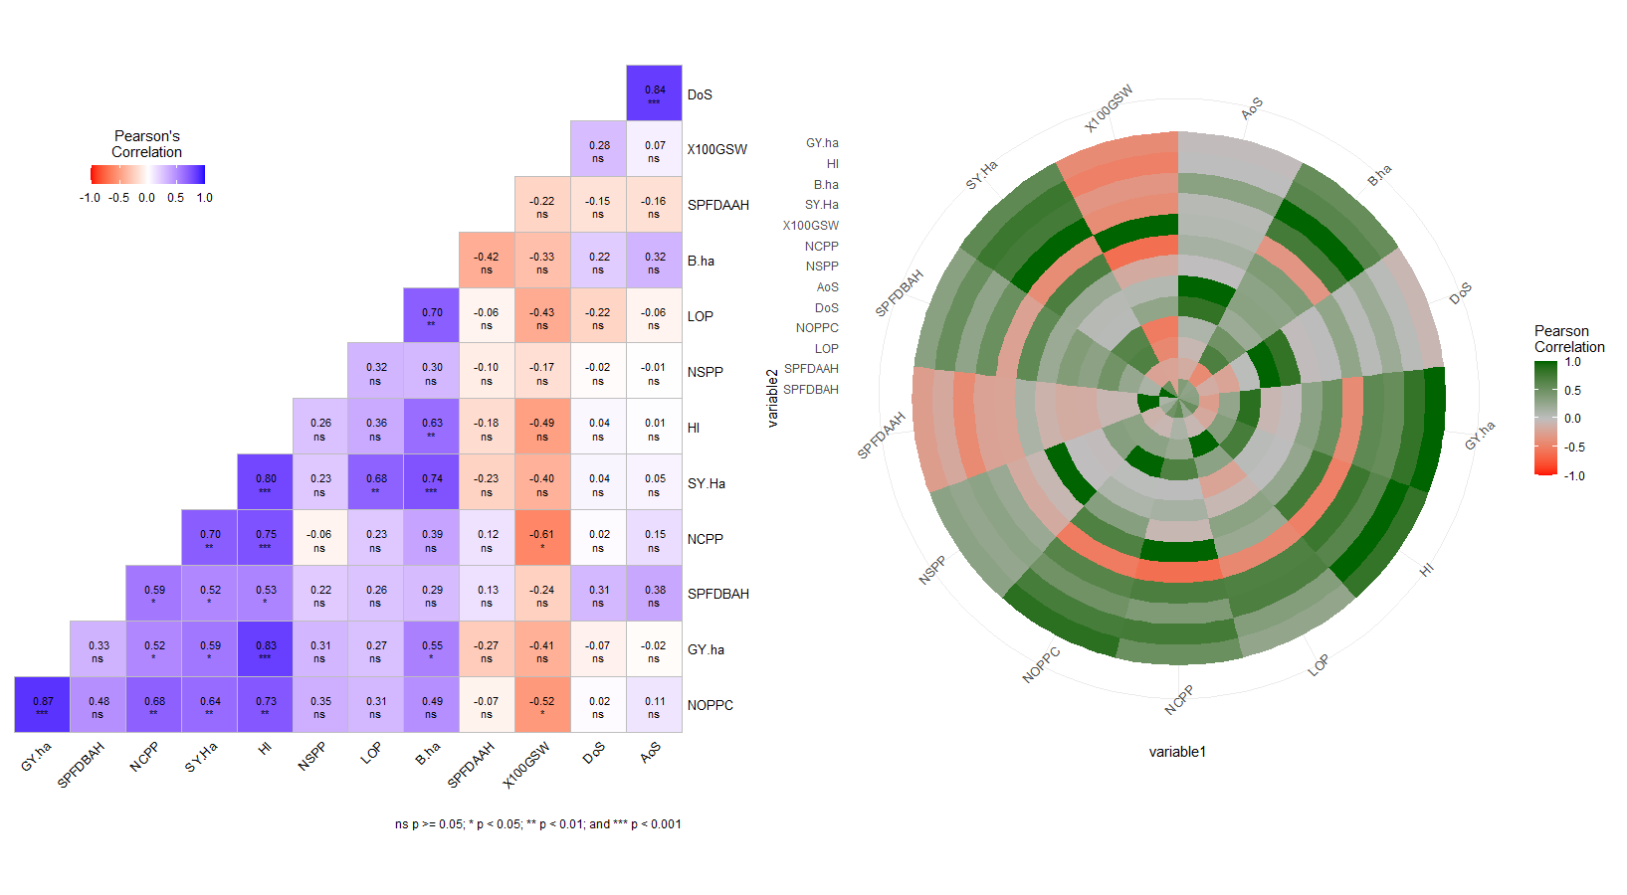

Figure 3 Correlation Matrix Heat Map of the Post Fertility-Associated Traits of the Mung Bean Genotypes and Promising Cultivars.

**Analysis of Regression Among Post-Fertilization Traits:**

Regression analysis is a statistical technique used to examine the relatiofnship between one or more predictor variables and a dependent variable (outcome)*Figure 4*. This analysis is commonly used to understand how changes in the predictor variables are associated with changes in the yield of mung bean genotypes and promising cultivars. However, the proportion of variation in yield that is predictable from a linear regression model is only about 10%. This suggests that the relationship between the variables that describe mung bean genotypes is non-linear or that there are other variables that affect yield but are not included in the model. Hence, this study used other multivariate techniques.

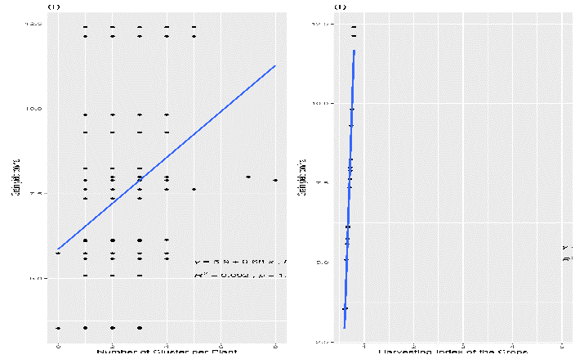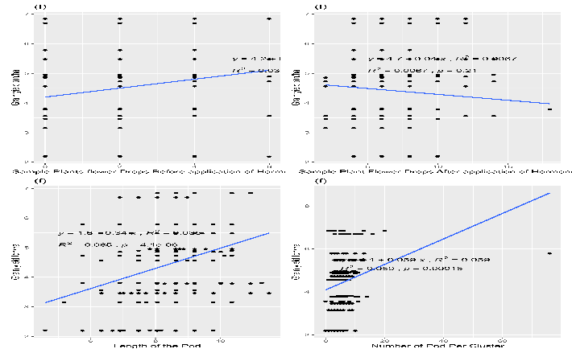

Figure 4 Regression analysis for post fertilization and yield related attributes of mung bean.

**Cluster Graph based on Euclidean distance Matrix.**

To determine the optimal number of clusters, the elbow technique was used, suggesting four clusters as the most effective. K-means clustering was applied to assess the diversity of 13 mung bean genotypes and 3 promising cultivars. In this analysis, pairwise dissimilarity among individuals based on 39 phenotypic descriptors, such as growth and yield-associated traits, was quantified using the Euclidean distance. The k-means clustering algorithm was then applied to group individuals into pre-specified clusters by maximizing the distance between individuals in different clusters. Four distinct clusters were identified, characterized by a dissimilarity CV of 0.172. Notably, 'KPS1' and 'Samrat' were grouped into the first cluster, which has the lowest intra-cluster dissimilarity Figure 5. In contrast, 'CN 95,' the whole-genome sequence genotype 'VC1973A', and other genotypes belonged to the third and largest cluster, containing three genotypes. The second-largest cluster, also comprising three genotypes, included 'Pratigya' and 'Pang Mung 2,' two promising cultivars. Finally, 'NM54' and various 'VC' series genotypes belonged to the first and highest cluster containing 6 genotypes. Intra and inter-cluster distances using the centroid linkage method are shown Table 6**.**

Table 6 Average intra-cluster (main diagonal) and inter-cluster (off-diagonal) of 16 genotypes centroid linkage method.

|  |  |  |  |  |
| --- | --- | --- | --- | --- |
| **Clusters** | c1 | c2 | c3 | c4 |
| c1 | **440.6875** |  |  |  |
| c2 | 5959.402 | **164.8274** |  |  |
| c3 | 2102.300 | 3901.142 | **409.9461** |  |
| c4 | 3798.374 | 2228.011 | 1702.288 | **229.3632** |

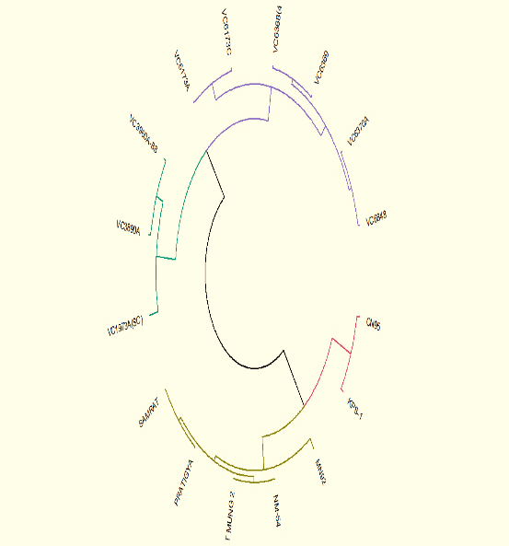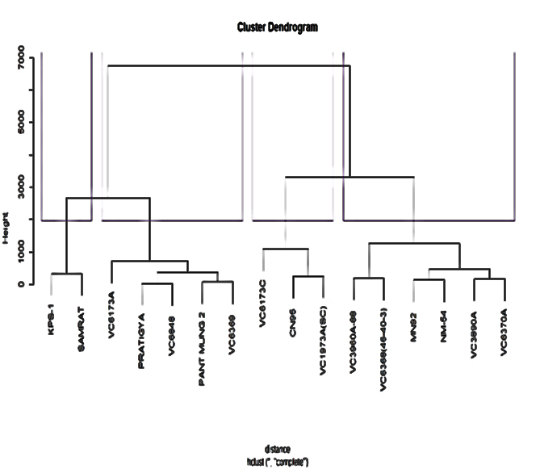

Figure 5 A dendrogram illustrating the degree of genetic similarity among various Mung Bean genotypes.

**Principal Components Analysis (PCA) to Investigate the Relationship Between Genotypic and Phenotypic Traits**

Singular Value Decomposition (SVD) and Principal Component Analysis (PCA) are two interrelated concepts in machine learning and data analysis. SVD is used to perform PCA in this study. Positive results in Dimension 1 are associated with eight variables: B.ha, GY.ha, HI, Y/SPP, Plot.Yield, SY.ha, X100GSW, and x45PH. These variables have mean values above the predefined threshold (indicated by the red dashed line). Conversely, the variables X30ENN, X30NDL, R.S ratio, RL, SL, BGWP, NOH.S, NSPP, AoS, and LOP account for a large portion of the variance in Dimension 2 (PC2). Dimension 3 is driven by A0S, DoS, LoS, and X45RNOD, while Dimension 4 (PC4) is significantly affected by variables like RL and NSPP, as shown in the following Figure 6.

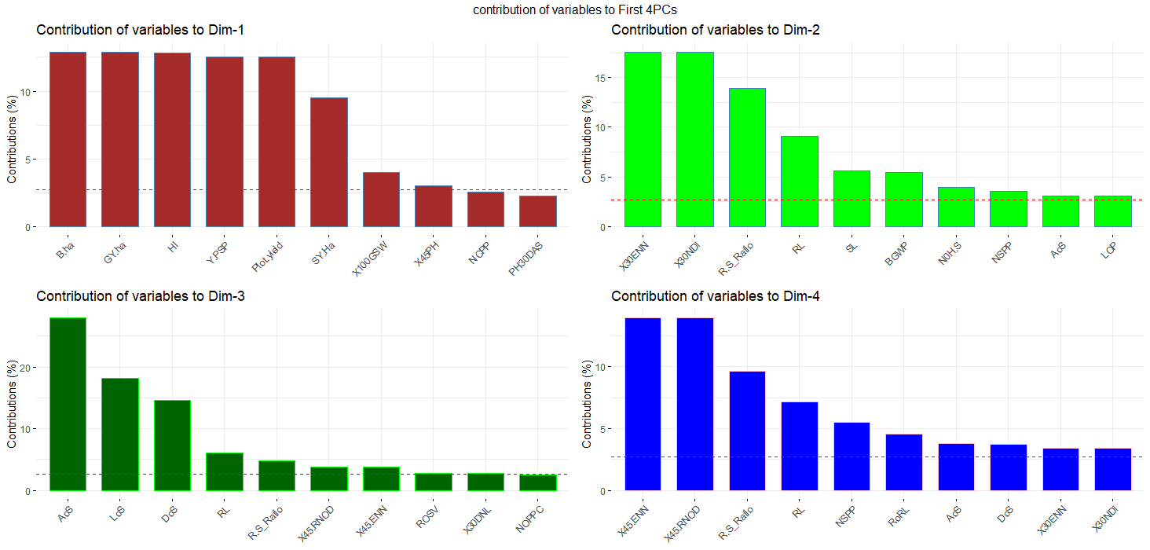

Figure 6 displays the percentage contributions of variables to the principal components (PCs) using distinct colors for each PC. The bars corresponding to PC1 are represented in brown, PC2 in light green, PC3 in dark green, and PC4 in blue. red dashed reference lines are overlaid across the bar plots. Variables with bars extending above these reference lines are considered significant contributors to their respective PCs.

Figure 7 shows the PCA scatter and loading plots for the key traits of mung bean genotypes. Using the first two components, all genotypes were correctly separated in all four quadrants (*Figure 10*). This genotype distribution clearly shows that the genotypes represent phenotypic variability and are well-distributed along both axes. The PCA (*Figure 8*) on quantitative data revealed that the first two dimensions (PC1 and PC2) accounted for most of the variance. The contribution of individual substances to sample differentiation is graphically represented as a correlation circle, with vectors representing the quantitative variables, normalized to unit length

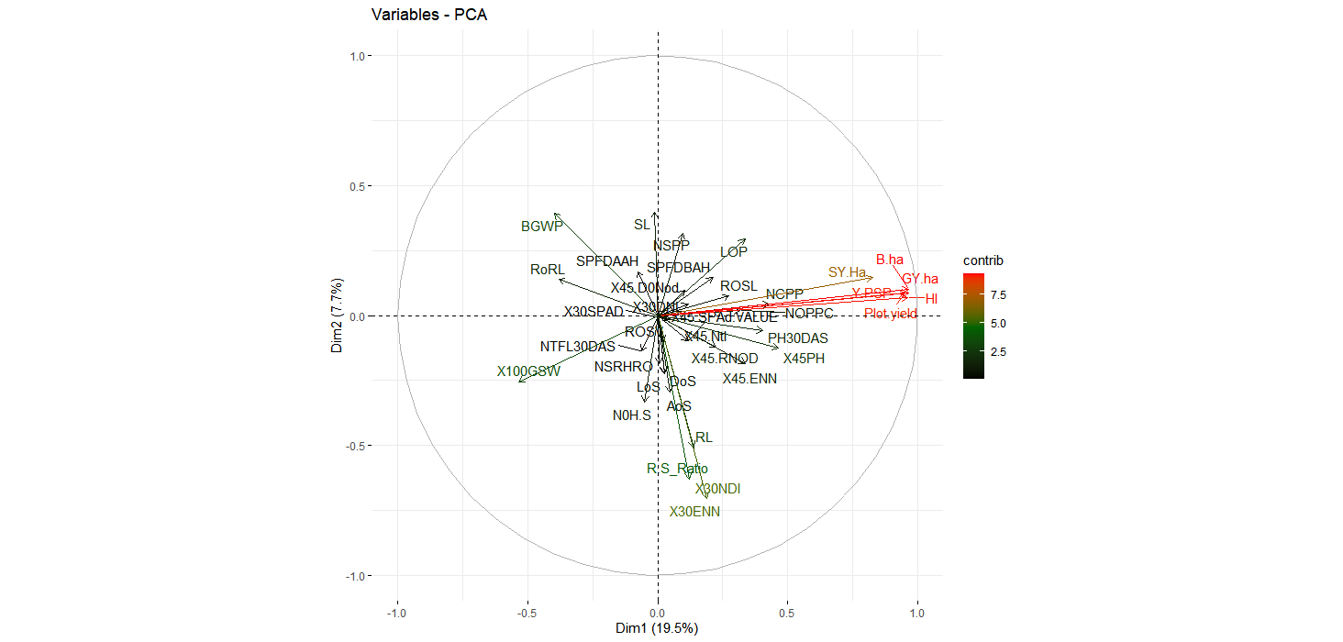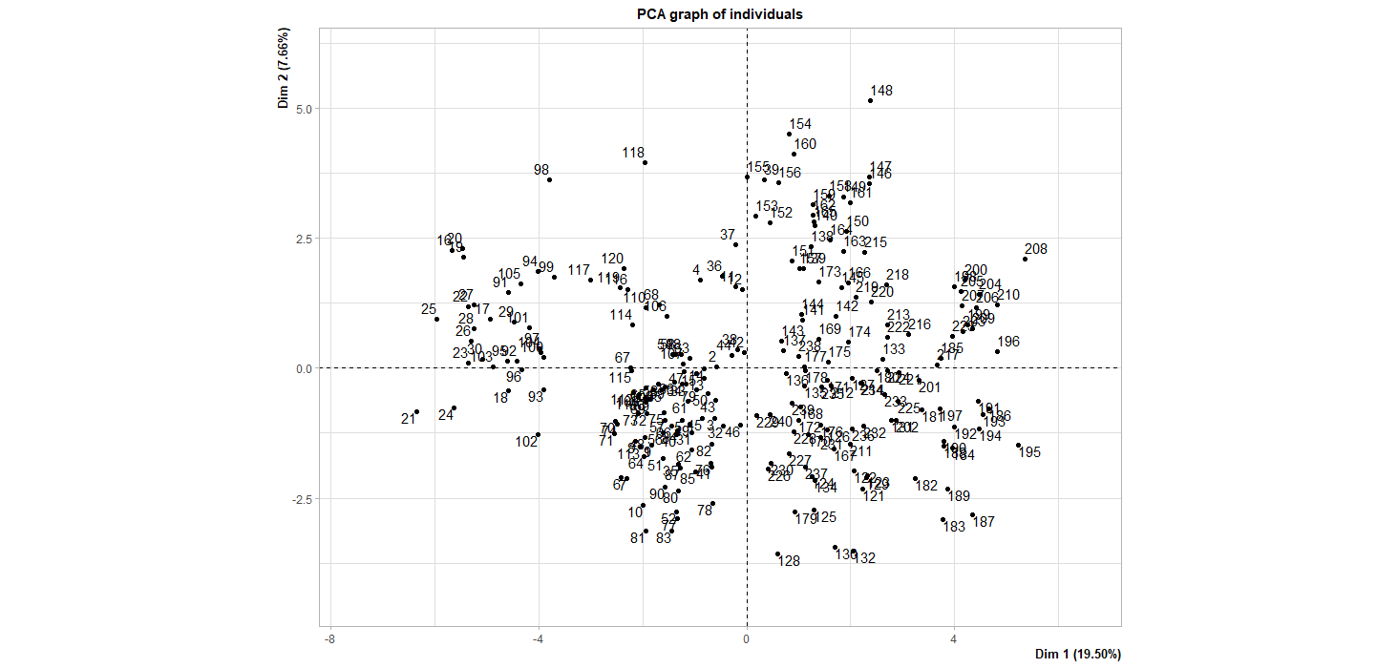

Figure 7 Representation of PCA Scatter Plots for Genotype Relationships and Variable Distribution in Mung Bean Analysis. RL=Root Length, SL=Shoot Length, R.S Ratio=Root to Shoot Ratio,N0H.S=Number of Secondary Roots, BGWP= Below ground White Portion,PH30DAS and X45PH= Plant Height 30 and Days after sowing, NTFL30DAS& X45.Ntl =Number of Tri-foliates leaves 30 and 45 DAS ,X30NDl & X30DNL=Number and Diameter of 30 days nodules, X30ENN & X45.ENN =effective number of root nodules 30 AND 45DAS,X30SPAD & X45.SPAd.VALUE=30 and 45DAS SPAD value,X45.RNOD= Root Nodules 45DAS,X45.D0Nod=45 Days Diameter of Nodules, LOP=Length of the Pod, NOPPC=Number of Pod Per Cluster, DoS & AoS=Diameter and Area of seed, NSPP=Number of seed/Pod, NCPP=Number of Cluster Per plant,X100GSW=100 Grain weight, SY.Ha= straw yield/ha, B.ha=Biological yield/ha, HI=Harvestig Index, GY.ha =Grain Yield/ha are used as experimental variables, respectively

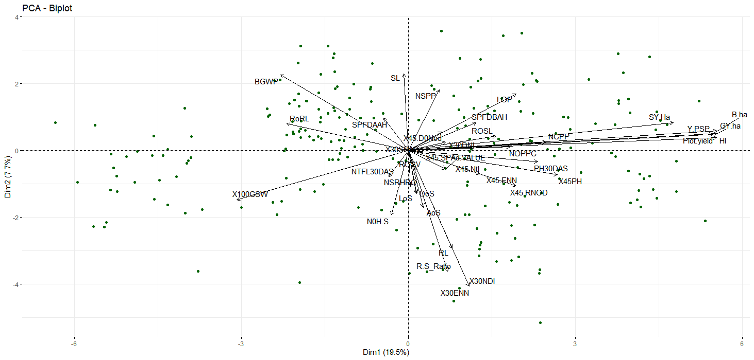

Figure 8 Graphical Representation of Relationships Among Experimental Attributes and Individual Data Points in the Top Two Principal Dimensions

In PC1, several attributes, including NTFL30DAS, NoH.S, X100GSW, R.S Ratio, PH 30DAS, PH45, NOPPC, SY.Ha, B.ha, LOP, NSPP, NCPP, and DoNod, made positive contributions to the variance, while the remaining attributes had a negative impact . In PC2, positive contributions were observed from features like BGWP, SPFAAH, NSPP, SL, SPFDAAH, ROSL, NCPP, SY.Ha, Y.PSP, GY.Ha, Plot yield, and HI, whereas NOHS, NTFL30DAS, NSRHRO, and X100GSW exhibited negative influences. It's worth noting that X100SW, NTFL30DAS, NSRHRO, NOH.S, and LOS traits displayed adverse contributions in both PCA dimensions.

The first dimension accounted for 19.5% of the total variance, while the second dimension contributed 7.7% to the overall variance. The length and direction of the vectors signified the significance of each variable. Smaller angles between vectors suggested a positive relationship, while a 180-degree angle implied a negative correlation. When the angle reached 90 degrees, it indicated no linear relationship between the variables. Among the 12 variables, X30DNDL, X45DoN, X30SPAD, ROSV, X45Ntl, NSRHRO, ROS, NTFL30DAS, DoS, AoS, and X30 and 45 SPAD values exhibit lower magnitude and shorter vector length. In contrast, BGWP, X100GSW, R.S ratio, X30NDL, X30ENN, B.ha, YPSP, and plot yield demonstrate a higher magnitude of variance compared to the remaining variables. Across 16 genotypes and promising mung bean cultivars, the red and green color vectors are closely related due to their narrow vector angles, indicating their strong interrelationship. Conversely, characteristics represented by opposing arrow directions, such as NCPP and X100GSW, show a negative correlation. *Table 7*provides essential information about Eigenvalues, variance percentages, and cumulative variance percentages for a total of 15 principal components. A noteworthy observation is that, collectively, these 15 components account for 100% of the total variance. However, the substantial portion of this variance, precisely 92%, is effectively explained by the initial 9 principal components. These 9 components meet the criteria defined by Kaiser, as they possess eigenvalues greater than 1.

Table 7 Eigenvalue estimates by principal components analysis and the proportion of variance explained by them

|  |  |  |  |
| --- | --- | --- | --- |
| Principle Component | Eigenvalues | Variance (%) | Cum. variance (%) |
| PC1 | 12.019 | **32.483** | 32.483 |
| PC2 | 5.020 | 13.568 | 46.051 |
| PC3 | 4.467 | 12.072 | 58.123 |
| PC4 | 2.997 | 8.100 | 66.223 |
| PC5 | 2.896 | 7.828 | 74.051 |
| PC6 | 2.136 | 5.772 | 79.822 |
| PC7 | 1.778 | 4.806 | 84.629 |
| PC8 | 1.418 | 3.832 | 88.461 |
| PC9 | 1.358 | 3.670 | 92.131 |
| PC10 | 0.902 | 2.438 | 94.570 |
| PC11 | 0.727 | 1.964 | 96.534 |
| PC12 | 0.508 | 1.373 | 97.907 |
| PC13 | 0.382 | 1.032 | 98.939 |
| PC14 | 0.244 | 0.658 | 99.598 |
| PC15 | 0.149 | 0.402 | 100.000 |

The scree plot provides a visual representation of eigenvalues and their respective contributions to the total variance **Figure 9**. The highest eigenvalue, notably 12.019, is attributed to the first principal component, explaining a substantial 7.5% of the variance, and an impressive 19.5% of the cumulative explained variance across all components. The initial five principal components collectively elucidate a significant portion, precisely 74%, of the total variance among the genotypes. The substantial eigenvalue of 12.019 for the first principal component underscores its significance in capturing a substantial portion of the variation in the phenotypic parameters of the genotypes. This information can be valuable to plant breeders, enabling them to effectively discern genotypes with the most desirable phenotypic attributes, thereby facilitating the differentiation of diverse genotype populations within Mung beans genotypes

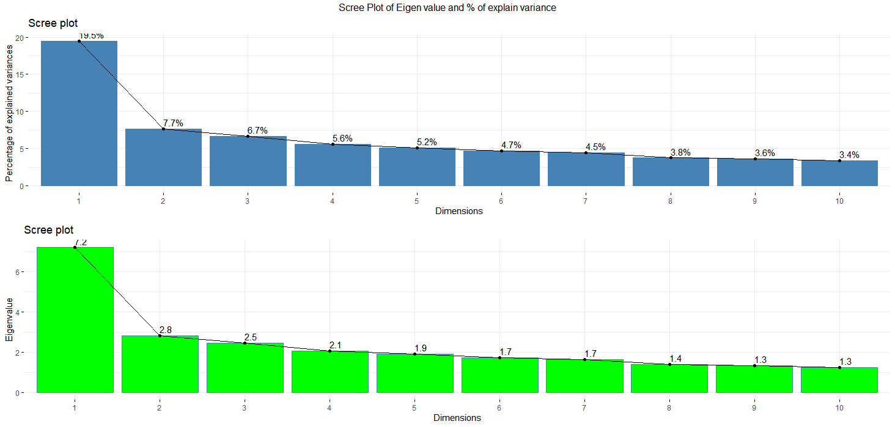

**Figure 9 Scree Plot Illustrating Eigenvalues and Percentage of Explained Variance for the Top 10 Principal Components, with Labels Representing the Variance Explained in Phenotypic Diversity of Mung-bean Genotypes by Each Components**

**Principal Component Analysis (PCA) Biplot and Ellipse Cluster Plot with Experimental Variables**

In the PCA Biplot, it's noteworthy that all the mung bean genotypes and promising cultivars are distributed across all four quadrants of the ellipse plot. However, when considering their distribution within these quadrants based on quantitative attributes, specific genotypes and promising cultivars tend to cluster in certain quadrants. The first cluster, predominantly represented by a brown triangle (designated as X100GSW), is particularly prominent. This cluster encompasses two promising cultivars, Samrat and KPS1, along with one genotype, VC6173C.Yield-associated traits are centrally clustered within the CN95 genotypes, which are indicated by a red plus sign. This suggests that the CN95 genotypes exhibit distinctive characteristics related to yield. The attribute related to 30-day root nodules (X30Ndl) is notably associated with the VC6370A genotype, represented by a green square sign. This indicates that VC6370A has a distinctive trait related to root nodules formation. Number of Sample Plant Flower Drops after application of hormones (SPFDAAH) is primarily linked to Pant Mung 2, symbolized by a blue circle *Figure 10*. This signifies that Pant Mung 2 stands out in terms of this particular attribute.

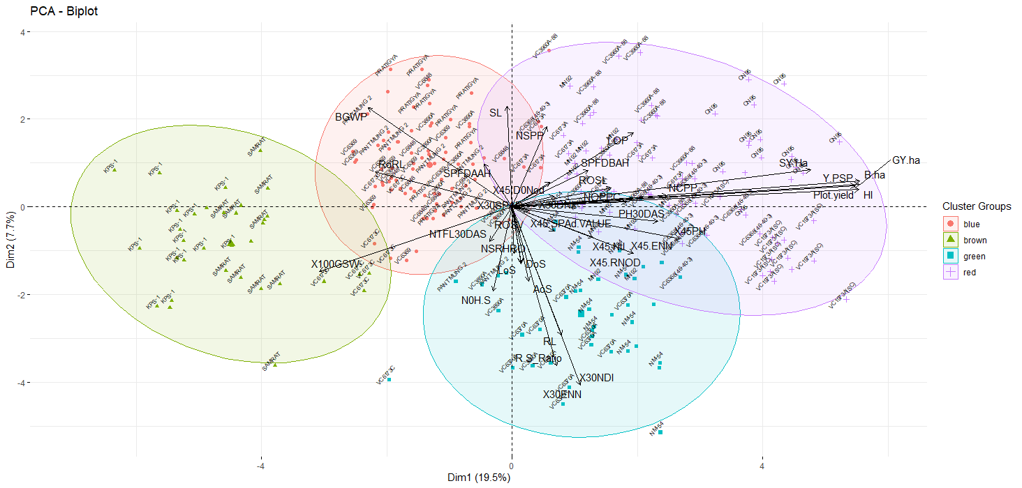

Figure 10 Graphical Representation of PCA Biplot and Ellipse Cluster Plot with Experimental Variables

**Identification of Ideal Mung bean Genotypes using Multi-Trait Stability Index (MTSI)**

Two genotypes, VC6370A followed by CN95, have been identified as the optimal genetic strains for mung-bean cultivation in Chitwan, based on a comprehensive analysis of key attributes highlighted in *Figure 11*. These genotypes are considered top-notch in terms of both stability, adaptability and overall performance among the varieties investigated. The average values of these chosen genotypes (Xs) were found to be higher than the original mean (Xo), which encompassed all 16 mung-bean genotypes, for all examined variables except SPFDAAH (Sample Plant flower drops after application of the hormone) and seeds per pod (NSPP). The selection difference (SD) was positive for all variables, except for NSPP and SPFDAAH. The heritability (h2) ranged from 0.157 for NOPPC to a perfect 1 for HI and X100GSW (as indicated in Table 6) followed by grain and biological yield/ha. Additionally, the selection gain (SG) was positive for all studied parameters except NSPP and SPFDAAH. The most substantial positive SG was observed at 27.113% for B.ha, while NOPPC showed the lowest SG value at 0.120%. Conversely, the negative SG ranged from -0.144% for NSPP to -0.683% for SPFDAAH *Table 9*.

**Contribution factor rank of the selected genotypes**

For the traits FA1, FA3, and FA4, FA7 CN95 ranked first, while FA2, FA6(Pre fertility Traits) and FA9 ranked first for VC6370A across all analyzed attributes *Table 8*. Consequently, the selected genotypes exhibit higher genotypic stability compared to the original population, which is a crucial aspect in genetic breeding efforts.

Table 8 Representation of the contribution factor rank of the selected genotypes. Exclusion of Genotypes FA5, FA6, FA7, and FA8 Due to Their Contribution to Pre-Fertilization Traits

|  |  |  |  |  |  |  |  |  |
| --- | --- | --- | --- | --- | --- | --- | --- | --- |
| **FA1** | **FA2** | **FA3** | **FA4** | **FA5** | **FA6** | **FA7** | **FA8** | **FA9** |
| CN95 | VC6370A | CN95 | CN95 | CN95 | VC6370A | CN95 | VC6370A | VC6370A |
| VC6370A | CN95 | VC6370A | VC6370A | VC6370A | CN95 | VC6370A | CN95 | CN95 |

Table 9 Summary of Selection Differential, Selection Gain, and Heritability Estimates Based on Multi-Trait Selection Index (MTSI) for Fourteen Post-Fertility-Associated Traits Assessed in Sixteen Mung Bean Germplasms

|  |  |  |  |  |  |  |  |  |  |
| --- | --- | --- | --- | --- | --- | --- | --- | --- | --- |
| **Variables** | **Factor** | **Xo** | **Xs** | **SD** | **SD%** | **h2** | **SG** | **SG%** | **sense** |
| SPFDBAH | FA1 | 0.779 | 0.930 | 0.150 | 19.299 | 0.226 | 0.034 | 4.353 | **decrease** |
| LOP | FA1 | 7.303 | 7.479 | 0.176 | 2.416 | 0.357 | 0.063 | 0.862 | increase |
| NOPPC | FA1 | 5.750 | 5.794 | 0.044 | 0.765 | **0.157** | 0.007 | 0.120 | increase |
| NCPP | FA1 | 2.283 | 2.467 | 0.183 | 8.027 | 0.361 | 0.066 | 2.901 | increase |
| SY.Ha | FA1 | 2999.625 | 3210.077 | 210.452 | 7.016 | 1.000 | 210.386 | 7.014 | increase |
| B.ha | FA1 | 10406.339 | 13229.841 | 2823.502 | 27.133 | **0.999** | 2821.425 | 27.113 | increase |
| HI | FA1 | 0.697 | 0.750 | 0.052 | 7.519 | 1.000 | 0.052 | 7.516 | increase |
| GY.ha | FA1 | 7.407 | 10.020 | 2.613 | 35.280 | **0.999** | 2.611 | 35.253 | increase |
| DoS | FA2 | 3.738 | 3.767 | 0.030 | 0.790 | 0.424 | 0.013 | 0.335 | increase |
| LoS | FA2 | 5.189 | 5.241 | 0.052 | 0.997 | 0.447 | 0.023 | 0.446 | increase |
| AoS | FA2 | 19.428 | 19.856 | 0.428 | 2.203 | 0.536 | 0.229 | 1.181 | increase |
| NSPP | FA3 | 6.500 > | 6.477 | -0.023 | -0.349 | 0.413 | -0.009 | -0.144 | increase |
| X100GSW | FA4 | 5.407 | 5.571 | 0.165 | 3.044 | 1.000 | 0.164 | 3.042 | increase |
| SPFDAAH | FA9 | 3.188 > | 3.107 | -0.080 | -2.522 | 0.271 | -0.022 | -0.683 | **decrease** |
| Xo: overall mean of genotypes; Xs: mean of the selected genotypes; SD: selection differential; SG: selection gain  or impact; h2: heritability; SPFDBAH & SPFDAAH: sample plant flower drops before and after application of the  hormone; LOP:length of pod; NOPPC: no of pod per cluster; SY.ha: straw yield/ha; B.ha: Biological yield/ha; HI:harvest index; DoS,AoS& LoS: Diameter, area and Length of seed; NSPP: no of seed per pod; X100GSW:100 grain seed weight. | | | | | | | | | |

communalities and uniqueness indicate the degree to which the post-fertility associated variables of mung bean share common variance and unique variance. communalities for the post-fertility associated variables of mung bean would indicate how much of the variance in each variable is explained by the underlying factors. uniqueness indicates the degree to which an observed variable has unique variance that is not shared with other variables in the dataset. The uniqueness for the post-fertility associated variables of mung bean would indicate how much of the variance in each variable is not explained by the underlying factors. Highest value (0.986) of communalities is expressed by biological yield/ha followed by two traits (0.981) yield/ha & harvesting index. The highest value of uniqueness is indicated by SPFDAAH followed by diameter of seed (DoS) is shown in given *Table 10*.

Table 10 Factorial Loadings After Varimax Rotation, Communalities, and Uniqueness for Post-Fertility Associated Variables of mung bean.

|  |  |  |  |  |  |  |  |
| --- | --- | --- | --- | --- | --- | --- | --- |
| **Variables** | **FA1** | **FA2** | **FA3** | **FA4** | **FA9** | **Comm** | **Uniq(1-Co)** |
| SPFDBAH | 0.558 | -0.397 | 0.038 | 0.058 | 0.302 | 0.886 | 0.114 |
| SPFDAAH | -0.060 | 0.166 | -0.234 | 0.014 | 0.793 | 0.843 | 0.157 |
| LOP | 0.639 | 0.197 | -0.249 | 0.247 | 0.118 | 0.944 | 0.056 |
| NOPPC | 0.747 | -0.116 | -0.265 | 0.308 | -0.228 | 0.885 | 0.115 |
| DoS | 0.126 | -0.749 | 0.106 | -0.291 | 0.071 | 0.857 | 0.143 |
| LoS | -0.053 | -0.849 | 0.084 | 0.286 | -0.093 | 0.868 | 0.132 |
| AoS | 0.057 | -0.926 | 0.122 | 0.036 | -0.010 | 0.921 | 0.079 |
| NSPP | 0.200 | 0.000 | -0.611 | 0.347 | -0.240 | 0.866 | 0.134 |
| NCPP | 0.755 | -0.196 | 0.041 | 0.363 | 0.106 | 0.888 | 0.112 |
| X100GSW | -0.432 | -0.180 | 0.000 | -0.701 | -0.184 | 0.887 | 0.113 |
| SY.Ha | 0.818 | -0.127 | -0.007 | 0.190 | -0.096 | 0.950 | 0.050 |
| B.ha | 0.971 | 0.042 | -0.021 | 0.038 | -0.133 | **0.986** | 0.014 |
| HI | 0.961 | 0.073 | 0.025 | 0.101 | -0.129 | 0.981 | 0.019 |
| GY.ha | 0.966 | 0.061 | -0.022 | 0.018 | -0.134 | 0.981 | 0.019 |
| SPFDBAH& SPFDAAH: sample plant flower drops before and after application of the hormone;LOP:length of pod; NOPPC: no of pod per cluster; SY.ha: straw yield/ha; B.ha: Biological yield/ha; HI:harvest index; DoS,AoS& LoS: Diameter, area and Length of seed; NSPP: no of seed per pod; X100GSW:100 grain seed weight. | | | | | | | |

**Assessment of Genotype Strengths and Weaknesses for Post Fertility Associated Traits.**

The factors that make up the MGIDI are divided into two categories: those that contribute more and those that contribute less. In the graphical representation, factors that contribute more to the MGIDI are closer to the center, while those that contribute less are closer to the edge. A dashed line shows what the MGIDI would be if all factors contributed equally *Figure 11*. The radar plot analysis revealed that FA1, which is related to grain yield and harvesting index, is the least important factor in the MGIDI of genotypes VC6368 (46-40-3), VC1973A(SC), and CN95. This indicates that these are the most productive genotypes among the selected ones. On the other hand, FA1 is more important in the MGIDI of KPS-1 and VC6173C, which suggests that these genotypes are less productive. This interpretation applies to other factors as well. Genotypes VC1973A(SC), CN95, VC6368 (46-40-3), VC3960A-88, and VC6173A have strengths associated with FA1 traits, which include grain yield and harvesting index-related characteristics. As all traits in FA1 benefit from positive gains, these genotypes should have high values for all three: LOP (Length of Pod), NOPPC (Number of Pods per Plant per Cluster), and NCPP (Number of Clusters per Plant).

FA2 contributing very little to the MGIDI in VC6370A and MN92 suggests that these genotypes have high values for DoS (Diameter of Seed), LoS (Length of Seed), and AoS (Area of Seed) compared to NM-54, where FA2 contributes more. The cultivar 'SAMRAT' has the highest contribution to FA3, indicating that it has a greater number of seeds per pod than VC6370A. VC6173C has the highest contribution to FA4, which pertains to the MGIDI index, due to its lower 100-grain seed weight compared to CN95. Lastly, FA9 exhibits the smallest contributions for VC6370A and CN95, signifying that these genotypes drop fewer flowers after hormone application within 24 hours. This shows that the flowers have finished blooming and have been pollinated. **Table 8** presents data related to the traits of the selected genotypes in comparison to the overall mean traits of all genotypes. This comprehensive approach helps to identify the best genotypes that can be used to breed guar varieties with high grain yield and other desirable characteristics.

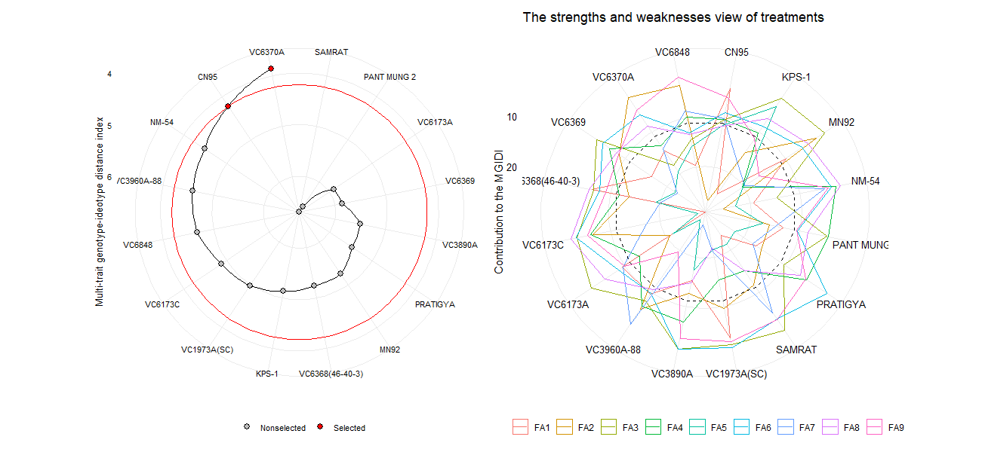

Figure 11 Graphics depicting the selected ideal and non-selected genotypes and the strength and weakness of MGIDI contributions to factor loading.

**Assessing Genetic Parameters Related to Post-Fertility Traits**

The results of the study show that there is a significant amount of variation in all of the parameters studied, both at the phenotypic and genotypic level. This suggests that there is a potential for genetic improvement of all of these parameters. The highest phenotypic coefficient of variation was highest for grain yield per hectare, followed by number of seeds per pod and 100 grain seed weight. The highest genotypic coefficient of variation was highest for grain yield per hectare, followed by number of seeds per pod and number of pods per cluster.

The genetic advance as percentage of mean was highest for grain yield per hectare, followed by number of seeds per pod and 100 grain seed weight. This suggests that there is a good potential for genetic improvement of these parameters. It is a measure of the expected improvement in a trait compared to the current mean. Breeder can select for genotypes with high values for the traits with the highest heritability and genetic advance. For example, breeders could select for genotypes with high grain yield per hectare, number of seeds per pod, and 100 grain seed weight controlling these traits. Over time, this would lead to a significant improvement in the grain yield of mung-bean Table 11.

Table 11 Estimation of genetic parameters for post-fertilization traits in different genotypes.

|  |  |  |  |  |  |  |  |  |  |  |
| --- | --- | --- | --- | --- | --- | --- | --- | --- | --- | --- |
| **Parameters** | **Grand Mean** | **CD@ 5%** | **Ve** | **Vg** | **Vp** | **GCV** | **PCV** | **ECV** | **GA** | **GAPM** |
| NOPPC | 5.75 | 8.49 | 27.81 | 8.58 | 36.39 | 50.94 | **104.92** | 91.72 | 2.93 | 50.95 |
| DoS | 3.74 | 0.49 | 0.09 | 0.11 | 0.21 | **8.99** | **12.15** | 8.16 | 0.51 | 13.72 |
| LoS | 5.19 | 0.99 | 0.22 | 0.29 | 0.51 | 10.44 | 13.81 | **9.03** | 0.84 | 16.28 |
| NSPP | 7.61 | 4.49 | 7.78 | 9.57 | 17.35 | 40.64 | 54.72 | 36.63 | 4.73 | 62.19 |
| X100GSW | 5.41 | 0.03 | 0.00 | 1.34 | 1.34 | 21.39 | 21.39 | 0.37 | 2.38 | 44.05 |
| HI | 0.58 | 0.00 | 0.00 | 0.02 | 0.02 | 22.10 | 22.10 | 0.31 | 0.27 | 45.53 |
| GY.ha | 4.43 | 0.09 | 0.00 | 9.56 | 9.57 | **69.74** | **69.75** | 1.30 | 6.37 | 143.64 |
| Critical Difference (CD) 5%, Environmental Variance (EV); Genotypic Variance (GV); Phenotypic Variance (PV); Environmental Coefficient of Variance (ECV); Genotypic Coefficient of Variance (GCV) , Phenotypic Coefficient of Variance (PCV); Genetic Advance(GA); Genetic Advance as percentage of mean(GAPM). NOPPC: # of pod/cluster; DoS: Diameter of seed; AoS: area of seed; NSPP: # of seed/pod; x100GSW:100 grain seed weight; HI: harvesting index; GY.Ha: Grain Yield/ha | | | | | | | | | | |

**Discussion**

Compared to other multivariate techniques such as the PCA biplot, cluster analysis is more effective in grouping genotypes into homogeneous subsets, which can help identify diverse parents or genotypes for use in breeding or other research programs. This is because cluster analysis can identify genotypes that are similar to each other across a wide range of traits, while the PCA biplot is more focused on identifying the most important traits that contribute to the overall variation in the data[28]. Cluster analysis can also help to bring together genotypes with desirable traits, which can minimize the number of generations needed to develop new varieties with improved performance. The results of the PCA analysis indicate that traits such as biological yield, grain yield, harvest index, yield of sample plant in a plot, straw yield, number of clusters per plant, number of seeds per plant, and 100-seed weight are the major variables associated with post-flowering and yield attributes in mung bean. Principal component 2 (PC2), which explains 46.051% of the total variation in the data, shows that the mung bean accessions are not randomly distributed. The non-random distribution of the mung bean accessions can be attributed to the presence of underlying factors that affect the expression of the genes in the accessions, such as environmental factors or genetic differences. This is consistent with the findings of [29], who reported that days to initial flowering, days to 50% flowering, flowering period, days to initial maturity, days to 80% maturity, 100-seed weight, and yield related traits. A biplot constructed using the results of the PCA analysis revealed that VC series genotypes such as VC6173-A, VC6368, VC1973A, VC3960-A-88, and CN95 belong to the plus sign biplot, which indicates that they have larger clusters for yield-related attributes. The findings of this study are in line with the results of a previous study that used PCA and path coefficient analysis to investigate the relationship between groundnut yield and seed quality attributes. [30]. In this study, Cluster C3 and cluster C4 have the shortest inter-cluster distance (1702.288), while cluster C2 has the shortest intra-cluster distance (164.8274). The cultivars CN95 and NM 54 belong to cluster C3, while the promising cultivars 'Pratigya' and 'Pant Mung' belong to cluster C2. The information obtained from clustering can be used to more efficiently identify novel genes, physiological mechanisms, polymorphic markers, and associations between markers and traits[31][5]. Table 11estimationof genetic parameters for mung bean traits shows that there is a high degree of genetic variation for all of the traits studied, except for HI (harvesting index). This is indicated by the high values for GCV (genotypic coefficient of variation) and PCV (phenotypic coefficient of variation). The high GCV and PCV values also indicate that these traits are highly heritable, meaning that they are strongly influenced by genetics. The high GA (genetic advance) values for all of the traits except for HI indicate that there is a lot of potential for improvement through selection. The highest GA values were observed for GY.Ha (grain yield/ha) and NSPP (number of seeds/pod). This suggests that these traits should be given priority in breeding programs aimed at improving mung bean yield. The GAPM (genetic advance as percentage of mean) values for all of the traits except for HI are also high, indicating that selection for these traits is likely to lead to a relatively large increase in grain yield. The highest GAPM value was observed for HI, indicating that this trait is of particular importance for improving mung bean yield. Overall, the results of the genetic parameter analysis suggest that there is a lot of potential for improving mung bean yield through selection. The traits with the highest priority for selection are GY.Ha, NSPP, and HI. So this result is aggred with the finding of variety of genes in cultivated mung bean plants and how this can be used to breed plants that produce more beans[32]

In Nepal, where more than three-quarters of mung-bean is grown in rainfed conditions, the Multi Trait Stability Index (MTSI) is a valuable tool for identifying mung-bean genotypes that are resistant to water stress. These genotypes can then be used in breeding programs to develop superior mung-bean varieties for rainfed conditions[33]. selected genotype VC6370A had a higher genotypic rank than CN95 for FA2, FA6, FA8, and FA9, which are associated with flowering and post-flowering traits. CN95 had a higher genotypic rank than VC6370A for FA1, FA3, FA4, FA5, and FA7. This demonstrates the high reliability of the genotype ranking, as the same protocols were used to select Tahiti acid lime genotypes using Bayesian inference[34]. The Multi Trait Stability Index (MTSI) analysis revealed that biological yield, grain yield, and harvesting index were the most stable traits, with factorial loadings of 0.971, 0.966, and 0.961, respectively. The least stable trait was diameter of seed, with a factorial loading of 0.12. Sample plant flower drops after application of hormone at an interval of 12 hours had a negative factorial loading of -0.06, indicating that it was unstable across environments. The highest factorial loading for factor 1 was 0.197 for length of the pod, and null for number of seeds per pod. All yield-related traits, such as length of the pod, number of pods per cluster, number of clusters per plant, straw yield per ha, harvesting index, and grain yield, were distributed on factor 1. Factor 2 consisted of diameter, length, and area of seed, FA4, and FA9, which consisted of single traits such as 100 grain seed weight and sample plant flower drops after application of hormone. MTSI analysis suggests that breeders have concentrated on developing genotypes with desired yield-related traits. However, all fertility-related traits, except for sample plant flower drops after application of hormone, need to be increased. Thus, Stable Genotypes have with improved morphological quantitative traits, such as clusters plant−1 , pods cluster−1 , grains pod−1 , branches plant−1 [12].A separate study of white Guinea yam genotypes found that the FAI-BLUP index technique could be used to identify genotypes that could be used as parents to breed new varieties with improved agronomic traits and end-product quality[35]**.** A multi-environment trial of rapeseed showed that the BLUP model could be used to select a single trait accurately. However, genotype recommendations based on a single trait, such as mean performance or stability, are incomplete and biased. Therefore, it is preferable to select genotypes based on multiple traits[36]. Thus, FAI-BLUP method is a statistical approach that uses structural equation modeling to rank genotypes based on their similarity to an ideal genotype, using multi-trait data without multicollinearity[37].

The present study investigated the impact of phytohormones applied at a standard rate on the flowering and post-flowering characteristics of mung bean genotypes within the rain-fed, subtropical climate of Chitwan, Nepal. The outcomes of this study revealed a significant and noteworthy influence of exogenously applied phytohormones on various key parameters. These parameters encompassed flower shedding, and post-flowering traits, such as the number of clusters per plant, number of pods per cluster, pod length, the number of seeds per pod, seed dimensions, pod count, pod length, straw yield, harvest index, and overall mung bean genotype yield, as depicted in (*Table 2***and** *Table 4***)**. The notable findings regarding the impact of phytohormones suggest that gibberellic acid (GA) may possess the capacity to intricately integrate with the flowering process. This integration appears to enable the fine-tuning of these responses, particularly when confronted with variable environmental factors in the field, such as fluctuations in moisture and temperature stress, as elucidated[38][39]. Similar outcomes were observed in a study where the combined foliar application of Indole-3-acetic acid (IAA) and Gibberellic acid (GA3), referred to as IAA2 + GA2, exhibited a notably robust impact on various yield attributes. This included a substantial increase of 66.0% in the number of pods, a remarkable 142.0% enhancement in pod weight, and a noteworthy boost of 106.5% in seed yield when compared to the control group[15]. In a separate investigation concerning soybean, the impact of 2,4-dichlorophenoxyacetic acid (2,4-DP) and Benzyl aminopurine (BAP) on pod set and seed yield during reproductive stages indicated a significant improvement in the 100-seed weight. Particularly, the application of 1 mM BAP resulted in a substantial increase to 22.3 g at the R1 stage[40]. Furthermore, an investigation into the pigeon pea species demonstrated that the foliar application of Naphthalene acetic acid (NAA) had a marked impact on reducing flower drop per plant and enhancing yield-attributing traits. Notably, the treatment with 80 ppm NAA exhibited superior efficacy in comparison to other treatments and the control group [41]. An additional study on mung beans revealed that foliar application of gibberellic acid GA3 at 200 ppm during the 30 and 60 days after sowing (DAS) had the potential to promote growth and enhance yield attributes and grain yield in mung beans[16]. In the context of green gram (Vigna radiata L.), a study investigated the impact of post-flowering management using plant growth regulators, with a particular focus on auxin and zeatin. Among the various treatments, the application of Nano-emulsion of NAA at 30 ppm demonstrated the most favorable results, manifesting in a higher number of mature pods, increased seed yield, greater seed weight, and a lower percentage of flower shedding [42]. A study centered on sesame (*Sesamum indicum L. cv*. Rama) evaluated the influence of plant growth regulators under moisture-stress conditions. Notably, the application of 200 ppm of these regulators yielded remarkable results in terms of growth, morpho-physiological characteristics, and seed yield [43]. These findings collectively underscore the significant influence of phytohormones and growth regulators on crop yield and associated attributes across various plant species, including mung beans, soybeans, pigeon peas, green gram, and sesame. This finding demonstrated a substantial degree of consistency with our original alternate hypothesis. To reinforce the effectiveness of phytohormone application in mung bean cultivation, additional research with an increased sample size and stricter environmental controls would be essential to recommend this study. Mung bean germplasm is highly diverse, and environmental factors can influence gene expression, so breeding has the potential to significantly improve yield. However, more research is needed to address study limitations, make SNP markers more accessible, and confirm water stress resistance under field conditions. Phytohormones can improve yield but are expensive and may have environmental impacts.

**Limitation of the Research and applications.**

* Genetic variation in cultivated mung bean germplasm is high and may be even greater than observed in this study.
* Environmental factors can influence the expression of genes that contribute to mung bean yield.
* Mung bean breeding has the potential to significantly improve yield, but more research is needed to address the limitations of current studies and make high-density SNP markers more accessible to breeders.
* Genotypes identified as resistant to water stress under controlled conditions may not express this resistance under field conditions.
* The mechanisms by which phytohormones affect flowering and post-flowering traits in mung beans are not fully understood.
* Phytohormones can be expensive to produce and apply, and they may have unintended environmental consequences.

**CONCLUSION**

**Mungbean breeding programs can improve yield by selecting for traits that are strongly correlated with yield, such as seeds per pod, clusters per plant, grain dimensions, hundred grain weight, and harvesting index.** The analysis of variance indicated highly significant variations among the 16 genotypes for all the traits. The results also showed that the application of naphthalene acetic acid (NAA) and gibberellic acid (GA3) at 50 mg/L each significantly increased yield attributes in mungbean, including total pods per plant, pod length, grains per pod, total grains per plant, and 100-grain weight.**This study found that these traits were also the most important for explaining the variation in yield among mungbean genotypes.** PCA also revealed that nine components had a significant effect on total diversity, while cluster analysis was helpful in selecting better genotypes. genotypes identified using the FAI-BLUP index technique can be used as parents to breed new mungbean varieties with desirable agronomic traits. Two genotypes, VC1973A and CN95, were selected as the most stable and high yielding(2.8tons/ha) among the 16 genotypes studied. The superior genotypes detected with higher genotypic values using the multi-trait selection index should be further exploited for possible commercial deployment in suitable production environments.

* WATER SATURATION DEFICIT: 100-RWC
* WATER RETENSION CAPACITY: TURGID WEIGHT/DRY WEIGHT (
* WATER UPTAKE CAPACITY: (TURGID WT-FRESH WT/DRY WT)

Referencess

[1] Y. J. Kang *et al.*, “Genome sequence of mungbean and insights into evolution within Vigna species,” *Nat. Commun.*, vol. 5, 2014, doi: 10.1038/ncomms6443.

[2] C. Liu *et al.*, “High-quality genome assembly and pan-genome studies facilitate genetic discovery in mung bean and its improvement,” *Plant Commun.*, vol. 3, no. 6, p. 100352, 2022, doi: 10.1016/j.xplc.2022.100352.

[3] K. Sandhu and A. Singh, “Strategies for the utilization of the USDA mung bean germplasm collection for breeding outcomes,” *Crop Sci.*, vol. 61, no. 1, pp. 422–442, 2021, doi: 10.1002/csc2.20322.

[4] “View of Mung bean proteins and peptides_ nutritional, functional and bioactive properties.pdf.” .

[5] M. G. Azam *et al.*, “Genetic Analyses of Mungbean [Vigna radiata (L.) Wilczek] Breeding Traits for Selecting Superior Genotype(s) Using Multivariate and Multi-Traits Indexing Approaches,” *Plants*, vol. 12, no. 10, 2023, doi: 10.3390/plants12101984.

[6] “j[mlif.”

[7] K. Basnet, N. Adhikari, and M. Pandey, “Multivariate Analysis among the Nepalese and Exotic Mungbean (Vigna Radiata L. Wilczek) Genotypes Based on the Qualitative Parameters,” *Univers. J. Agric. Res.*, vol. 2, no. 5, pp. 147–155, 2014, doi: 10.13189/ujar.2014.020502.

[8] “Electronic Journal of Plant Breeding Genetic analysis in ashwagandha [ Withania somnifera ( L .),” vol. 12, no. May 2020, pp. 804–811, 2021.

[9] S. Paliwal, S. Sharma, and N. Pathak, “Principal component analysis in mungbean [ Vigna radiata L . Wilczek ] genotypes under two seasons,” vol. 11, no. 3, pp. 1500–1505, 2022.

[10] F. S. Koij and J. Saba, “Using Cluster Analysis and Principal Component Analysis to Group Lines and Determine Important Traits in White Bean,” *Procedia Environ. Sci.*, vol. 29, no. Agri, pp. 38–40, 2015, doi: 10.1016/j.proenv.2015.07.145.

[11] S. Debnath *et al.*, “Principal Component and Path Analysis for Trait Selection Based on the Assessment of Diverse Lentil Populations Developed by Gamma-Irradiated Physical Mutation,” *Biomed Res. Int.*, vol. 2022, 2022, doi: 10.1155/2022/9679181.

[12] N. K. Benakanahalli *et al.*, “A Framework for Identification of Stable Genotypes Basedon MTSI and MGDII Indexes: An Example in Guar (Cymopsis tetragonoloba L.),” *Agronomy*, vol. 11, no. 6, p. 1221, 2021, doi: 10.3390/agronomy11061221.

[13] D. Taleghani, A. Rajabi, A. Saremirad, and P. Fasahat, “Stability analysis and selection of sugar beet ( Beta vulgaris L .) genotypes using AMMI , BLUP , GGE biplot and MTSI,” *Sci. Rep.*, pp. 1–14, 2023, doi: 10.1038/s41598-023-37217-7.

[14] S. Munda, M. Paw, S. Saikia, T. Begum, J. Baruah, and M. Lal, “Stability and selection of trait specific genotypes of Curcuma caesia Roxb.using AMMI, BLUP, GGE, WAAS and MTSI model over three years evaluation,” *J. Appl. Res. Med. Aromat. Plants*, vol. 32, no. November 2022, 2023, doi: 10.1016/j.jarmap.2022.100446.

[15] A. Parveen *et al.*, “Effect of Natural Phytohormones on Growth, Nutritional Status, and Yield of Mung Bean (Vigna radiata L.) and N Availability in Sandy-Loam Soil of Sub-Tropics,” *Soil Syst.*, vol. 7, no. 2, pp. 1–17, 2023, doi: 10.3390/soilsystems7020034.

[16] M. S. Islam *et al.*, “Water relations and yield characteristics of mungbean as influenced by foliar application of gibberellic acid (GA3),” *Front. Ecol. Evol.*, vol. 11, no. January, 2023, doi: 10.3389/fevo.2023.1048768.

[17] “2021_Ha et al A near‐complete genome sequence of mungbean Vigna radiata L provides key insights into.pdf.” .

[18] M. P. Neupane, H. Musalman, and S. K. Sah, “Influence of Sowing Date on Phenology, Biometric, and Yield of Mungbean (Vigna radiata) Cultivars in Chitwan, Nepal,” *Int. J. Agron.*, vol. 2023, 2023, doi: 10.1155/2023/8927439.

[19] N. Shukla, H. Kuntal, A. Shanker, and S. N. Sharma, “Hydro-Priming Methods for Initiation of Metabolic Process and Synchronization of Germination in Mung Bean (Vigna Radiata L.) Seeds,” *J. Crop Sci. Biotechnol.*, vol. 21, no. 2, pp. 137–146, 2018, doi: 10.1007/s12892-018-0017-0.

[20] M. F. El Karamany, M. S. Sadak, and B. A. Bakry, “Improving quality and quantity of mungbean plant via foliar application of plant growth regulators in sandy soil conditions,” *Bull. Natl. Res. Cent.*, vol. 43, no. 1, 2019, doi: 10.1186/s42269-019-0099-5.

[21] J. Markwell, J. C. Osterman, and J. L. Mitchell, “Calibration of the Minolta SPAD-502 leaf chlorophyll meter,” *Photosynth. Res.*, vol. 46, no. 3, pp. 467–472, 1995, doi: 10.1007/BF00032301.

[22] Z. Kamarianakis and S. Panagiotakis, “Design and Implementation of a Low-Cost Chlorophyll Content Meter,” *Sensors*, vol. 23, no. 5, 2023, doi: 10.3390/s23052699.

[23] A. Schneider, G. Hommel, and M. Blettner, “Lineare regressionsanalyse - Teil 14 der serie zur bewertung wissenschaftlicher publikationen,” *Dtsch. Arztebl.*, vol. 107, no. 44, pp. 776–782, 2010, doi: 10.3238/arztebl.2010.0776.

[24] R. Bam, S. R. Mishra, S. Khanal, P. Ghimire, and S. Bhattarai, “Effect of biofertilizers and nutrient sources on the performance of mungbean at Rupandehi, Nepal,” *J. Agric. Food Res.*, vol. 10, no. October, p. 100404, 2022, doi: 10.1016/j.jafr.2022.100404.

[25] C. M. Donald and J. Hamblin, “The Biological Yield and Harvest Index of Cereals as Agronomic and Plant Breeding Criteria,” *Adv. Agron.*, vol. 28, no. C, pp. 361–405, 1976, doi: 10.1016/S0065-2113(08)60559-3.

[26] T. Olivoto and M. Nardino, “Genetics and population analysis MGIDI : toward an effective multivariate selection in biological experiments,” vol. 37, no. December 2020, pp. 1383–1389, 2021, doi: 10.1093/bioinformatics/btaa981.

[27] G. W. Burton and E. H. Devanez, “from Replicated Clonal Material ’,” pp. 478–481, 1953.

[28] K. Tripathi *et al.*, “Cowpea genetic resources and its utilization: Indian perspective – A review,” *Legum. Res.*, vol. 42, no. 4, pp. 437–446, 2019, doi: 10.18805/LR-4146.

[29] K. Tripathi *et al.*, “Understanding genetic variability in the mungbean ( Vigna radiata L .) genepool,” no. November 2019, pp. 1–12, 2020, doi: 10.1111/aab.12624.

[30] “Principal Component Analysis and Path Coefficient Analysis for Groundnut Yield and Seed Quality Attributes ( Arachis hypogaea L . ),” pp. 1–7, 2023, doi: 10.18805/LR-5075.Submitted.

[31] W. N. Id *et al.*, “Population structure and genetic diversity analyses of common bean germplasm collections of East and Southern Africa using morphological traits and high-density SNP markers,” pp. 1–23, 2020, doi: 10.1371/journal.pone.0243238.

[32] T. Yimram, P. Somta, and P. Srinives, “Genetic variation in cultivated mungbean germplasm and its implication in breeding for high yield,” *F. Crop. Res.*, vol. 112, no. 2–3, pp. 260–266, 2009, doi: 10.1016/j.fcr.2009.03.013.

[33] T. Hussain, Z. Akram, G. Shabbir, A. Manaf, and M. Ahmed, “Saudi Journal of Biological Sciences Identification of drought tolerant Chickpea genotypes through multi trait stability index,” vol. 28, pp. 6818–6828, 2021.

[34] J. Santana, P. Coelho, and R. Silva, “Scientia Horticulturae Multitrait and multiharvest analyses for genetic assessment and selection of Tahiti acid lime genotypes through Bayesian inference Marco Ant o,” vol. 290, no. April, 2021.

[35] D. Genotypes, P. E. Norman, P. A. Agre, and R. Asiedu, “Multiple-Traits Selection in White Guinea Yam,” pp. 1–15, 2022.

[36] Z. Li and W. Wu, “Genotype recommendations for high performance and stability based on multiple traits selection across a multi-environment in rapeseed,” vol. 145, no. June 2022, 2023.

[37] “Selection indexes based on linear‐bilinear models applied to soybean breeding.pdf.” .

[38] R. Castro-Camba, C. Sánchez, N. Vidal, and J. M. Vielba, “Plant Development and Crop Yield: The Role of Gibberellins,” *Plants*, vol. 11, no. 19, 2022, doi: 10.3390/plants11192650.

[39] G. S. S. khattak, I. Saeed, and T. Muhammad, “Flowers’ shedding under high temperature in mungbean (Vigna radiata (l.) Wilczek),” *Pakistan J. Bot.*, vol. 41, no. 1, pp. 35–39, 2009.

[40] Y. Cho, S. K. Suh, H. K. Park, and A. Wood, “Impact of 2,4-DP and BAP upon pod set and seed yield in soybean treated at reproductive stages,” *Plant Growth Regul.*, vol. 36, no. 3, pp. 215–221, 2002, doi: 10.1023/A:1016590505449.

[41] K. Sharvani, V. Naik, M. Krishi Vidyapeeth, I. J. Deshmukh, S. V Kalyankar, and J. D. Deshmukh, “Effect of foliar spray of NAA (Naphthalene acaetic acid) on flower drop and seed yield of pigeonpea (Cajanus cajan (L.) Millsp.),” *~ 1172 ~ Pharma Innov. J.*, vol. 11, no. 1, pp. 1172–1175, 2022, [Online]. Available: http://www.thepharmajournal.com.

[42] B. K. Priya, S. Panneerselvam, S. Marimuthu, K. S. Subramanian, and A. Senthil, “Post Flowering Management Using Plant Growth Regulators in Greengram (Vigna radiata L.),” *Int. J. Plant Soil Sci.*, vol. 34, no. 24, pp. 535–543, 2022, doi: 10.9734/ijpss/2022/v34i242670.

[43] A. K. Garai and J. K. Datta, “Influence of plant growth regulators on growth, morpho-physiological characters and yield of summer sesame (Sesamum indicum L. cv. Rama) under moisture stress,” *Acta Physiol. Plant.*, vol. 21, no. 3, pp. 277–281, 1999, doi: 10.1007/s11738-999-0043-7.